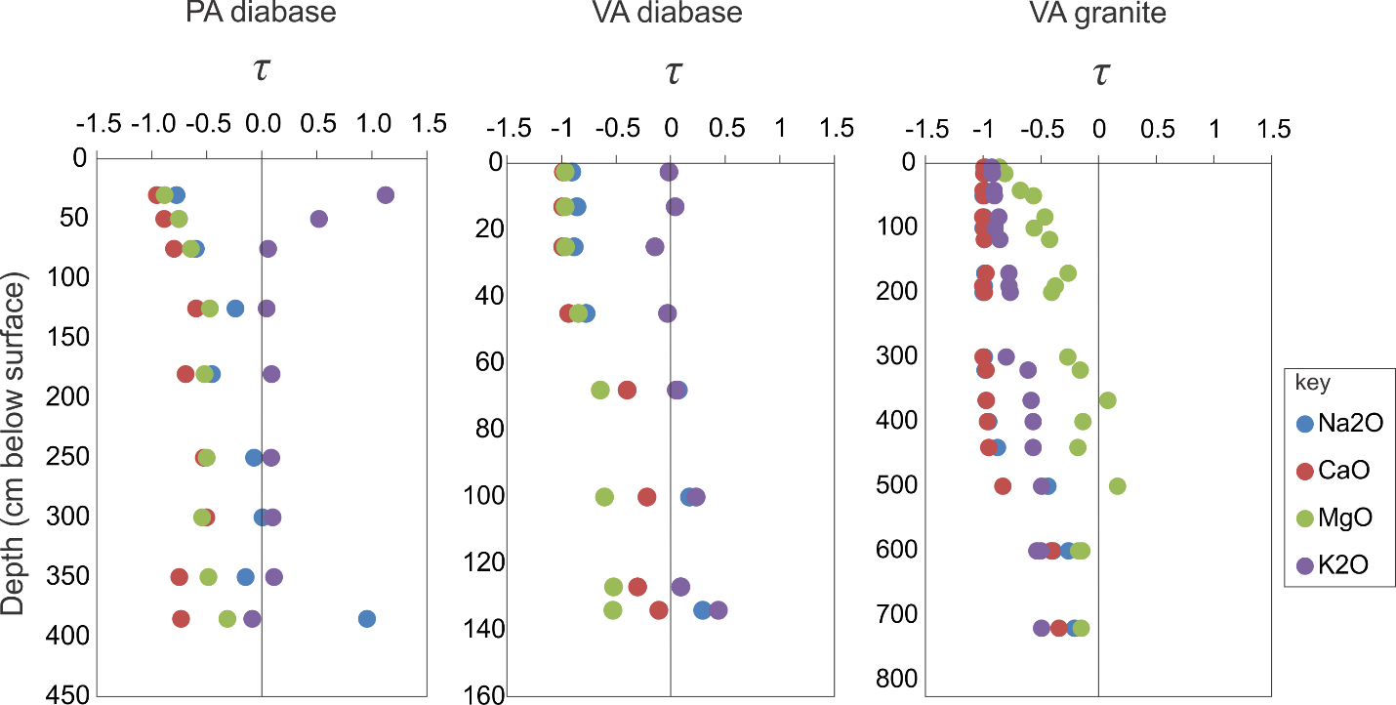

Supplemental Figure 1. Tau plots for PA diabase, VA diabase and VA granite.

