**PROTEROZOIC-MESOZOIC DEVELOPMENT OF THE QUANJI BLOCK FROM NORTHERN TIBET AND THE CRATONIC ASSEMBLY OF EASTERN ASIA**

Chao Wang[1],[2], David A.D. Evans**, Meng Li***, Ji-Heng Zhang****, Jian Han*, Bin Wen*****, Jian Wang***, and Junfeng Zhao*

**Contents of this file**

**Appendix A. Analysis Methods**

**Appendix B. Stratigraphy and Depositing Setting**

**Appendix C. Zircon U-Pb Result of the Hongzaoshan Formation**

**Table S1. Sample Descriptions/Locations**

**Table S2. Detrital** **Zircon U-Pb Analysis Data**

**Table S3. Major and trace element compositions of basalts from the Shiyingliang Formation**

**Figure S1. Examples of Detrital Zircon CL Images**

**Figure S2. Photographs of the representative sections in Quanji block.**

**Figure S3. Photomicrographs of the felsic volcanics from the Hongzaoshan Formation.**

**Figure S4. Photographs of the Quanji Group.**

**Figure S5. Photographs of the Xiaogaolu and Olongbuluke groups.**

**Figure S6. Comparative tectono-stratigraphic time-space chart of Tarim, Quanji block, southern NCB, and SCB.**

**Appendix A. Analysis Methods**

U–Pb zircon geochronology was completed for 18 samples collected from Paleoproterozoic to Cambrian sedimentary and volcanic rocks in Quanji Block and 3 samples from southern margin of Noth China Block (tables S1 and S2). Zircon grains were separated using conventional heavy liquid and magnetic techniques, and were mounted into epoxy resin blocks and polished to obtain flat surfaces. This was followed by cathodoluminescence (CL) imaging of individual zircon grains with a Mono CL3+ microprobe to image the internal structures of grains (see fig. S1). Laser ablation–inductively coupled plasma–mass spectrometry (LA-ICP-MS) dating was conducted over a period of five years on two different instruments at the Tianjin Institute of Geology and Mineral Resources, Chinese Geological Survey and the State Key Laboratory of Continental Dynamics in Northwest University, Xi’an, China, respectively. Simultaneous measurement of U-Pb isotopic compositions of zircons was preformed using a quadrupole and multiple-collector inductively-coupled-plasma mass spectrometer (Q-ICP-MS and MC-ICP-MS, respectively) connected to a single excimer laser-ablation system. During analysis, the spot diameter was 33 μm. ICP-MS operating conditions were generally optimized using continuous ablation of reference glass NIST SRM 610, to provide maximum sensitivity for the high masses while maintaining low oxide formation and low background. Concentrations of U, Th and Pb were calibrated by using 29Si as the internal standard and NIST SRM 610 as the external standard. Ratios of 207Pb/206Pb and 206Pb/238U were calculated using the GLITTER 4.0 program, and then corrected using the Harvard zircon 91500 as the external standard. Apparent and discordia U-Pb ages were calculated using the ISOPLOT software (Ludwig, 2008). The detailed instrumental parameters and analytical procedures are documented by Yuan and others (2008). The 207Pb/206Pb age was used for grains older than 1500 Ma, and the 206Pb/238U age was used for younger grains (e.g. Spencer and others, 2016). Only data with concordance in the range 90–105% were considered for interpretation of zircon ages. Concordia diagrams (2σ error ellipses) were produced using the Isoplot Excel program (Ludwig, 2008) and normalized age-distribution (relative age probability) diagram using methods outlined in Gehrels (2012). Zircon U–Pb age data are given in supplementary dataset (table S2). In addition, the Shiyingliang Formation mafic volcanic rocks located in the Quanjishan area were selected for whole-rock chemistry analysis at the State Key Laboratory of Continental Dynamics in Northwest University, Xi'an. Fresh whole rock chips were powdered to 200 mesh-size using a tungsten carbide ball mill. Major and trace elements were analyzed by XRF (Rikagu RIX 2100) and ICPMS (Agilent 7500a), respectively. Analyses of USGS and Chinese national rock standards (BCR-2, GSR-1 and GSR-3) indicate that analytical precision and accuracy for major elements are generally better than 5%. For trace element analysis, sample powders were digested using an HF+HNO3 mixture in high-pressure Teflon bombs at 190 °C for 48 h. Analytical precision is better than 10% for most trace elements. For more detailed information about geochemical data, refer to table S3.

**Appendix B. Stratigraphy and Depositing Setting**

1. **Quanji Group**

**Mahuanggou Formation:** The Mahuanggou Formation shows a thickening to the west, from 431 m at Olongbuluke to 458 m in Quanjishan, with westward fining grain-size trends (fig. 3). The lower part of the Mahuanggou Formation comprises a basal conglomerate that unconformably overlies the metamorphic basement (figs. S4A and S4B), and coarsening upward conglomeratic arkose with cross bedding and parallel bedding; with rounded quartzite and pebble-sized clasts likely sourced from the underlying Dakendaban Complex. Conglomerates and sandstones are moderately to poorly sorted and contain subrounded to rounded clasts of quartzite, chert, and granitic materials. The middle member contains upward-fining large-scale wedge and parallel cross-bedded conglomerate and arkosic quartz sandstone. The upper member contains coarse-grained arkosic sandstone. Mudstone and siltstone beds are lacking in the Mahuanggou Formation. Layers of quartz pebble conglomerate and pebble lags are locally present. The conglomerate and sandstone beds indicate deposition within alluvial fans and braided river.

**Kubaimu Formation:** The Kubaimu Formation conformably overlies the Mahuanggou Formation. This unit dramatically thickens westward, ranging in thickness from 129 to 355 meters, from Olongbuluke to Quanjishan (fig. 3). The lower and middle members of Kubaimu Formation consist of a fining upward sequence. The lower member is dominated by reddish-gray conglomerate intercalated with quartz arenite. The middle member contains reddish conglomerate-bearing quartz arenite. The upper member contains medium- to fine-grained quartz arenite with ooidal iron-rich quartz sandstone and pebbly arenite. Herringbone cross-bedding, symmetrical and asymmetrical ripple marks and mud cracks are well developed in the quartz arenite. The overall sedimentary succession in the Kubaimu Formation indicates deposition during a transgression, toward coastal facies.

**Shiyingliang Formation:** The Shiyingliang Formation ranges in thickness from 203 to 395 meters. This unit thickens eastward from Quanjishan to Olongbuluke (fig. 3). The contact of the Kubaimu and Shiyingliang Formations is a stratigraphic discontinuity represented by a prominent erosional surface in the Olongbuluke area, which contains thin conglomerate with clasts derived from the underlying Kubaimu Formation. The lower member of the Shiyingliang Formation consists of yellowish-green silty mudstone, grey glauconite-bearing quartz siltstone, argillite and interbedded fine-grained quartz sandstone, and two yellowish-green basaltic beds (fig. S4C). The middle member consists of grey argillite, banded iron formation (BIF) and interbedded ooidal hematite-rich quartzite (fig. S4D) that was deposited from suspension. The upper member contains grey tuffaceous siltstone, black silty mudstone, and ooidal iron-rich quartz arenite. The upper member has two upward-coarsening facies changes, showing a lower shale-rich portion grading up to a sandstone rich upper portion (fig. S4E). Cross stratification is well developed throughout the formation. The glauconite-bearing quartz siltstone interbedded with quartzite sandstone above the basaltic volcanic layers are characterized by mudcracked, well-rounded sandy gravel beds and raindrop imprints of backshore environments (Wang and others, 1980). The abundance of glauconite and hematite in the Shiyingliang Formation indicates an unusually large flux of continental chemical weathering, restricted circulation, and high rates of sedimentation in coastal-shelf depositional conditions, mostly within the shoreface region. The prominently laminated shale and mudstone in the Olongbuluke sections may also suggest cyclic lacustrine facies.

**Hongzaoshan Formation:** The Hongzaoshan Formation is variably developed. In the Olongbuluke region of eastern Quanji block, only the lower two members are present. This unit dramatically thickens westward, from 119 meters at Olongbuluke, to 355 and 298 meters at Shihuigou, and Quanjishan, respectively (Fig. 3). Previous work interpreted the contact between the Shiyingliang and Hongzaoshan formations as transitional and conformable (Wang and others, 1980). New mapping in this study suggests that these formations are in fault contact. The lower member of the Hongzaoshan Formation consists of purplish, thin to medium-bedded, medium to coarse-grained tuffaceous sandstone and laminated micrite, interbedded thin mudstones, and rhyolite, ignimbrite (fig. S4F), and lentiform tuff, with some units bearing jasper and halite pseudomorphs. At Shihuigou, an association with slumping and convoluted deformation and wormkalk (Wang and others, 2015a) indicates the behavior of dense, unconsolidated rocks on top of unconsolidated sediments in a tectonically unstable region (e.g., storm deposition). The middle member is thick dark-gray dolostone with *Cryptozoon* and *Conophyton* stromatolites. Near the base of the middle dolostone, some chert and dolostone clasts are recognized (fig. S4G). The upper member is thick and massive well-bedded stromatolitic dolostone, with *Cryptozoon* stromatolites (fig. S4H). Jasper associated with rhyolitic ignimbrite may possibly represent diagenetic silica concretions. Bedding in the dolostone displays grading that thickens upward and indicates times of both decreased siliciclastic input and more spatially uniform sedimentation. These features indicate deposition in a shallow platform environment.

**2.** **Heitupo Formation:** The Heitupo Formation is developed in the Quanjishan region, but is absent in the Shihuigou and Olongbuluke regions (fig. 3). This unit dramatically thickens westward, ranging in thickness from 41 to 123 meters. In the Quanjishan area, the unconformity surface is followed by the Heitupo Formation. At the base of the Heitupo Formation, there is yellowish-green, thin to medium-bedded dolomicrite with hematite layers and a weathering crust (<5 m thick). The lower member is black carbonaceous shale with hematite concretions. The upper member of the Heitupo Formation is composed of greenish-gray mudstone (fig. S5A). The Heitupo Formation represents a marine shelf deposit.

**3. Xiaogaolu Group**

**Hongtiegou Formation:** In the Quanjishan region, the Hongtiegou Formation is ~4-20 m thick and the Hongtiegou diamictite is gradational, and the lower member of the Hongtiegou Formation is marked by the presence of dolostone, chert and sandstone pebbles (up to 2 m) in laminated greenish/reddish mudstone with ferroan and dolomitic matrix (fig. S5B). Quartzite clasts are lithologically likely derived from the underlying Quanjishan Group detrital rocks. Dolomite clasts may have been eroded from strata of the originally underlying Hongzaoshan Formation. The upper member is thinly bedded, pebbly sandstone with angular dolomite dropstones; and laminated shale deposits point to a relatively quiet depositional environment. In the Shihuigou area, the Hongtiegou Formation is distinguished from that of the Quanjishan by being a coarser and thicker-bedded, massive, matrix-supported diamictite. It is 13-88 m thick and contains pebble to boulder (up to 4 m) clasts in a dark red, silty dolomitic matrix (fig. S5C). Clasts are mostly dolostone, along with lesser amounts of quartzite. The matrix is brown colored, where rich in carbonate. This massive diamictite rests unconformably on the Hongzaoshan Formation. At Oulongbluke, the Hongtiegou Formation is absent (fig. 3). Overall, the extensive deposits of diamictite are interpreted to be of glacial or glaciomarine origin based on the presence of striated and faceted clasts, lonestones, and dropstones. Clasts range in size from pebbles to boulders and consist of dolostone, quartzite and sandstone derived from the underlying older formations of the Quanji Goup, requiring denudation and recycling of underlying units.

**Zhoujieshan Formation:** The Zhoujieshan Formation is thicker in the Quanjishan region (21-48 m) and thins eastward to as little as 2 m at Shihuigou (2-20 m), and is absent in Olongbuluke region (fig. 3). The Hongtiegou glacigenic diamictite is overlain by a ~3–7-m-thick unit of gray dolostone which has been interpreted as a ‘cap carbonate’ deposited during deglaciation from a Snowball Earth glacial event (fig. S5D), with positive δ13C values ranging from 0‰ to +1.7‰ (Shen and others, 2010). The lowermost cap of the Zhoujieshan Formation is 3–7-m thick conglomeratic (dolomitic clasts) dolomite, the upper cap consisting of thinly laminated sandy dolomite. These carbonates may represent condensed sections of carbonate sediment and a reduction of the clastic sediment supply during postglacial transgression and landward migration of point sources of sediment. Other parts of the Zhoujieshan Formation are exclusively composed of reddish or greenish thin-laminated siltstone/fine sandstone (fig. S5E). The *Charnia* and ribbon-shaped fossils are developed in the uppermost Zhoujieshan sandstone. Hence, the succession consists of tidal flat facies in shallow marine facies during deglaciation and sea-level rise.

**4. Olongbuluke Group**

The newly defined Xiaogaolu Group is overlain by the Olongbuluke Group in the Quanjishan and Shihuigou regions (fig. 3). In the Olongbuluke region, the middle member of Olongbuluke Group overlies the Hongzaoshan Formation directly. There is a disconformable surface marked by dark gray phosphatic and chert concretions at the base of Olongbuluke Group (fig. S5F). The Olongbuluke Group consists predominantly of limestone and dolomite with reddish siltstone interbeds in open platform deposits. This 260 limestone contains unusual features of oncolite. Brachiopods (*Kutorgina sp., Obulus sp.*), echinoderm fragments and hyolith fossils occur in the phosphatic concretions, suggesting a Cambrian age for this unit (Wang et al., 1980).

**Appendix C. Zircon U-Pb Result of the Hongzaoshan Formation**

Zircons from these felsic volcanic rocks are euhedral to subhedral. In cathodoluminescence (CL) images, some grains display very fine oscillatory zoning with faint CL indicating their magmatic origin (Fig. S1). Some grains contain CL-dark cores but bright rims, and may represent inherited and xenocrysts. Sample 17QJ-1 (rhyolite) yields the age spread of concordant grains ranging from 2484 Ma to 1522 Ma. The five youngest grains with light luminescence and oscillatory zoning provide an average 207Pb/206Pb age of 1622 ± 69 Ma (MSWD = 0.71, n=5; fig. 6A). The oldest ages from the dark luminescent zircon grains yielded ages ranging from 1801±53 Ma to 2615±36 Ma, suggesting xenocrystic origin (fig. 6A). The youngest age population, of sixteen of the 21 analyses from light luminescent zircon grains of sample 17QJ-3 (lentiform tuff), yield a weighted-mean 207Pb/206Pb age of 1650±25 Ma (MSWD = 0.14, n=15; fig. 6B). Xenocrystic grains (unzoned zircon grains with the dark luminescence, n = 5) yielded ages ranging from 1894±35 Ma to 2077±37 Ma (fig. 6B). Twenty-four analyses were conducted on 24 zircon grains from sample 17SH-3 (rhyolite), yielding concordant results and a weighted mean 207Pb/206Pb age of 1663±22 Ma (MSWD = 0.47, n=23; fig. 6C). Thirteen of the 18 analyses from light luminescent zircon grains of sample 17QJ-9 (rhyolite) yield a weighted-mean 207Pb/206Pb age of 1674±36 Ma (MSWD = 0.32, n=13; fig. 6D). Xenocrystic grains (n = 4) yielded ages ranging from 1794±45 Ma to 2427±22 Ma (fig. 6D). Sample 13SHE-1 (ignimbrite) yields main age groups of 1.60–1.75 Ma, 1.85–2.2 Ga, and 2.3–2.6 Ga, with dominant peaks at ca. 1650 and 2400 Ma (fig. 6E). Three youngest grains give an average 207Pb/206Pb age of 1620 ± 15 Ma (MSWD = 0.0022). Nevertheless, all samples contain prominent ca. 1.65 Ga age peaks (fig. 6), which are clearly younger than the reported ages from the underlying Mahuanggou and Kubaimu formations.

**References**

BGMS, 1989. Regional geology of Shaanxi Province: Beijing, Geological Publishing House, 698 p (in Chinese).

BGMX, 1993. Regional geology of Xinjiang Uygur Autonomous Region: Beijing, Geological Publishing House, Beijing, 841 p (in Chinese).

Gehrels, G., 2012. Detrital Zircon U-Pb Geochronology: Current Methods and New Opportunities. In Tectonics of Sedimentary Basins: Recent Advances. John Wiley and Sons, p. 45–62.

Geng, Y.S., Kuang, H.W., Liu Y.Q., and Du, L.L., 2017. Subdivision and Correlation of the Mesoproterozoic Stratigraphy in the Western and Northern Margins of Yangtze Block: Acta Geologica Sinica, v. 91(10), p. 2151-2174.

Ludwig, K.R., 2008, Isoplot 3.60: Berkeley Geochronology Center Special Publication 4, 77 p.

Shen B, Xiao S, Zhou C., Kaufman, A.J., and Yuan, X., 2010. Carbon and sulfur isotope chemostratigraphy of the Neoproterozoic Quanji Group of the Chaidam Basin, NW China: basin stratification in the aftermath of an Ediacaran glaciation postdating the Shuram event?: Precambrian Research, v. 177, p. 241–252.

Spencer, C. J., Kirkland, C. L., and Taylor, R. J. M., 2016, Strategies towards statistically robust interpretations of in situ U-Pb zircon geochronology: Geoscience Frontiers. V. 7, p. 581-589.

Wang, C., Li, M., Li R.S., Peng, Y., Zhang, J.H., Zhang, H.J., and Wang, J., 2015a, Recognition of the regional unconformity in the Neoproterozoic Quanji Group on the north margin of the Qaidam Basin in Qinghai Province: Geological Bulletin of China, v. 34(2/3), p. 364–373.

Wang, C., Li, R.S., Li, M., Meert, J., and Peng, Y., 2015b. Palaeoproterozoic magmatic-metamorphic history of the Quanji Massif, Northwest China: implications for a single North China-Quanji-Tarim craton within the Columbia supercontinent: International Geology Review, v. 57 (13), p. 1772–1790.

Wang, X.L., Jiang, S.Y., Dai, B.-Z., Griffin, W.L., Dai, M.N., and Yang, Y.H., 2011. Age, geochemistry and tectonic setting of the Neoproterozoic (ca 830 Ma) gabbros on the southern margin of the North China Craton: Precambrian Research, v. 190, p. 35-47.

Wang, C., Liu, L., and Li, R.S., 2018. Precambrian geology of the northern margin of the Tibetan Plateau: Review and discussion: Chinese Journal of Geology, v. 53(3), p. 972-999.

Wang, Y.S., Zhuang, Q., Shi, C., Liu, J., and Zheng, L., 1980, Quanji Group along the northern border of Chaidamu Basin, *In*: Tianjin Institute of Geology and Mineral Resources, editors, Research on Precambrian Geology Sinian Suberathem in China: Tianjin, v.1, p. 214–230.

Wang, Z.J., Wang, J., Jiang, X.S., Sun, H.Q., Gao, T.S., Chen, J.S., Qiu, Y.S., Du, Q.D., Deng, Q., Yang, F., 2015c. New progress for stratigraphic division and correlation of Neoproterozoic in Yangtze Block, South China: Geological review, 61(1), p. 1-22.

Xu, B., Xiao, S.H., Zou, H.B., Chen, Y., Li, Z.X., Song, B., Liu, D.Y., Zhou, C.M., and Yuan, X.L., 2009. SHRIMP zircon U-Pb age constraints on Neoproterozoic Quruqtagh diamictites in NW China: Precambrian Research, v. 168, p. 247–258.

Xu, X., Song, S.G., Allen, M.B., Ernst, R.E., Niu, Y.L., and Su, L., 2016. An 850–820 Ma LIP dismembered during breakup of the Rodinia supercontinent and destroyed by Early Paleozoic continental subduction in the northern Tibetan Plateau, NW China: Precambrian Research, v. 282, p. 52–73.

Yuan, H.L., Gao, S., Dai, M.N., Zong, C.L., Günther, D., Fontaine, G.H., Liu, X.M., and DiWu, C.R., 2008. Simultaneous determinations of U–Pb age, Hf isotopes and trace element compositions of zircon by excimer laser ablation quadrupole and multiple collector ICP–MS: Chemical Geology, v. 247, P. 100–118.

Zhang, C.L., Ye, X.T., Ernst, R.E., Zhong, Y., Zhang, J., Li, H.K., and Long, X.P., 2019a. Revisiting the Precambrian evolution of the Southwestern Tarim terrane: Implications for its role in Precambrian supercontinents: Precambrian. Research, v.324, p.18–31.

Zhang, H., Gao, L.Z., Zhou, H.R., Song, B., Ding, X.Z., Zhang, C.H., Liu, H.G., and Gong, C.Q. 2019b. Chronology progress of the Guandaokou and Luoyu groups in the southern margin of North China Craton: constraints on zircon U-Pb dating of tuff by means of the SHRIMP: Acta Petrologic Sinica, v. 38(8), p. 2470-2486.

Zhang, H.J, Wang, X.L, Wang, X., and Zhou, H.R., 2016. U-Pb zircon ages of tuff beds from the Hongzaoshan Formation of the Quanji Group in the northern margin of the Qaidam Basin, NW China, and their geological significances: Earth Science Frontiers, v. 23(06), p. 202–218.

Zhao, T., and Deng, X., 2016. Petrogenesis and Tectonic Significance of the Late Paleoproterozoic to Early Mesoproterozoic (~1.80–1.53 Ga) A-Type Granites in the Southern Margin of the North China Craton. *In*: Zhai, M., Zhao, Y., Zhao, T., editors, Main Tectonic Events and Metallogeny of the North China Craton: Springer Geology. Springer, Singapore. pp. 423–434.

**Table S1.** SUMMARY OF SAMPLING IN THE QUANJI BLOCK AND NORTH CHINA BLOCK.

|  |  |  |  |  |  |  |  |  |  |  |  |  |  |  |  |  |  |  |  |  |  |  |  |  |  |  |  |  |  |  |  |  |  |  |  |  |  |  |  |  |  |  |  |  |  |  |  |  |  |  |  |  |  |  |  |  |  |  |  |  |  |  |  |  |  |  |  |  |  |  |  |  |  |  |  |  |  |  |  |  |  |  |  |  |  |  |  |  |  |  |  |  |  |  |  |  |  |  |  |  |
| --- | --- | --- | --- | --- | --- | --- | --- | --- | --- | --- | --- | --- | --- | --- | --- | --- | --- | --- | --- | --- | --- | --- | --- | --- | --- | --- | --- | --- | --- | --- | --- | --- | --- | --- | --- | --- | --- | --- | --- | --- | --- | --- | --- | --- | --- | --- | --- | --- | --- | --- | --- | --- | --- | --- | --- | --- | --- | --- | --- | --- | --- | --- | --- | --- | --- | --- | --- | --- | --- | --- | --- | --- | --- | --- | --- | --- | --- | --- | --- | --- | --- | --- | --- | --- | --- | --- | --- | --- | --- | --- | --- | --- | --- | --- | --- | --- | --- | --- | --- | --- |
| |  |  |  |  |  |  | | --- | --- | --- | --- | --- | --- | | Group | Formation | Sample | Locality | Rock description | coordinate | | Olongbuluke Group | *Olongbuluke Formation* | 13SQL-33 | Quanjishan | chert | E95.823248° N37.424599° | | *13SHW-4* | Shihuigou | coarse sandstone | E96.051525°N37.372478° | | *13SQL-28* | Quanjishan | pebble-bearing sandstone | E95.821841°N37.427369° | | *13SQL-27* | E95.821997°, N37.426910° | | Xiaogaolu Group | *Zhoujieshan Formation* | 14SH-4 | Shihuigou | greenish-gray sandstone | E96°6.2732′  ,N37°22.2262′ | | 13SQL.32 | Quanjishan | reddish sandstone | 95.826901°,37.420994° | | 13SQL.31 | 95.827152°,37.421188° | | 13SQL.20 | 95.798770°,37.430190° | | *Hongtiegou Formation* | 13SQL.30 | Quanjishan | diamictite | 95.827542°,37. 421601° | | Quanji Group | *Hongzaoshan Formation* | 17QJ-1 | Quanjishan | rhyolite with phenocrysts of plagioclase and quartz, embedded in a fine-grained groundmass | 95.801315°,37.432125° | | 17QJ-3 | Quanjishan | lentiform tuff | 95.801640°,37. 432772° | | 13SHE-1 | Shihuigou | ignimbrite marked by deformed minerals and lithic fragments | 96.0833722000°37.3680419000° | | 17QJ-9 | Shihuigou | rhyolite with phenocrysts of plagioclase and quartz, embedded in a fine-grained groundmass |  | | 17SH-3 | Shihuigou | 96°4.8977′,37°21.9430′ | | *Kubaimu Formation* | 14OL-2 | Olongbuluke | quartzitic sandstone | 96.451795°,37.37280780° | | 13SHW-1 | Shihuigou | 96.057292°,37.380719° | | 12.92.R2 | Quanjishan | 95.826482°,37.408062° | | *Mahuanggou Formation* | 12.76.1 | Quanjishan | pebbly sandstone | 95.924618°,37.369684° | | (North China Block) | Xinji Formation | 17QL-1 | Zhifang | sandy limestone | 110°15.4367′,34°15.9225′ | | 17QL-2 | Zhifang | quartzitic sandstone | 110°15.4367′,34°15.9225′ | | Luoquan Formation | 16SNCB-2 | Xiazhangwan | diamictite | 110°8.4480′,34°15.1860′ |   **Table S3.** MAJOR AND TRACE ELEMENT COMPOSITIONS OF BASALTS FROM THE SHIYINGLIANG FORMATION | | | | | | | |
| Sample | 13SQL-24(1) | 13SQL-24(5) | 13SQL-25(1) | 13SQL-25(2) | 13SQL-25(3) | 13SQL-25(4) | 13SQL-25(5) |
| SiO2 | 48.54 | 46.62 | 52.07 | 49.08 | 54.31 | 49.54 | 49.24 |
| Al2O3 | 15.14 | 13.75 | 13.5 | 13.98 | 14.33 | 13.95 | 14.06 |
| Fe2O3T | 4.35 | 3.35 | 8.98 | 3.81 | 3.18 | 9.34 | 3.67 |
| MgO | 8.29 | 8.86 | 6.23 | 7.04 | 9.96 | 6.81 | 6.94 |
| CaO | 9.72 | 3.26 | 5.64 | 6.32 | 0.53 | 1.87 | 6.39 |
| Na2O | 1.3 | 0.12 | 2.65 | 2.38 | 0.41 | 0.17 | 2.33 |
| K2O | 2.59 | 5.69 | 0.39 | 1.77 | 4.06 | 6.88 | 1.89 |
| TiO2 | 1.12 | 1.13 | 1.37 | 0.93 | 0.93 | 0.91 | 0.91 |
| P2O5 | 0.11 | 0.1 | 0.13 | 0.11 | 0.11 | 0.11 | 0.1 |
| MnO | 0.15 | 0.11 | 0.17 | 0.12 | 0.04 | 0.05 | 0.12 |
| LOI | 1.38 | 8.84 | 4 | 9.28 | 5.88 | 5.32 | 9.12 |
|  |  |  |  |  |  |  |  |
| Cu | 111 | 108 | 56.2 | 44.9 | 41.5 | 10.3 | 48.6 |
| Pb | 3.66 | 2.43 | 9.86 | 7.25 | 2.48 | 10 | 5.38 |
| Zn | 71.5 | 36.1 | 101 | 89.2 | 51.8 | 42.7 | 74.7 |
| Cr | 144 | 152 | 65.8 | 67.1 | 63.8 | 71.2 | 66.7 |
| Ni | 88.9 | 79.1 | 39.2 | 43.2 | 40.9 | 35.7 | 40.7 |
| Co | 51.3 | 45.9 | 48.7 | 45.2 | 41.9 | 29.9 | 42.4 |
| Li | 24.3 | 23.7 | 23.2 | 24.1 | 29.1 | 23.4 | 23.3 |
| Rb | 30.6 | 69.9 | 6.2 | 34.5 | 42.7 | 98.2 | 37.8 |
| Cs | 2.5 | 0.44 | 0.45 | 0.8 | 0.77 | 1.41 | 0.94 |
| Sr | 174 | 158 | 342 | 178 | 29.6 | 71.2 | 176 |
| Ba | 108 | 346 | 242 | 455 | 694 | 1290 | 327 |
| V | 248 | 246 | 313 | 233 | 235 | 193 | 235 |
| Sc | 32.7 | 21.7 | 28 | 28.8 | 23.6 | 31.4 | 26.1 |
| Nb | 6.35 | 6.32 | 7 | 5.32 | 5.24 | 5.28 | 5.24 |
| Ta | 0.51 | 0.51 | 0.56 | 0.42 | 0.41 | 0.42 | 0.41 |
| Zr | 74.6 | 75.2 | 110 | 88.5 | 89.5 | 88.8 | 88.7 |
| Hf | 2.03 | 2.13 | 3.39 | 2.49 | 2.58 | 2.69 | 2.54 |
| Be | 0.45 | 0.4 | 0.82 | 0.84 | 0.88 | 1.21 | 0.81 |
| Ga | 15.8 | 16.2 | 20.3 | 17 | 15.2 | 18.2 | 17.2 |
| Ge | 1.18 | 1.34 | 1.9 | 1.19 | 1.26 | 1.6 | 1.19 |
| U | 0.38 | 0.52 | 0.75 | 0.63 | 0.91 | 0.68 | 0.61 |
| Th | 0.64 | 0.62 | 1.39 | 1.69 | 1.42 | 2 | 1.6 |
| La | 6.3 | 7.27 | 10.9 | 10.2 | 7.65 | 12.2 | 10.2 |
| Ce | 15.5 | 17.3 | 25.8 | 23.2 | 18.4 | 27.2 | 22.8 |
| Pr | 2.19 | 2.37 | 3.55 | 3.02 | 2.54 | 3.5 | 3.05 |
| Nd | 9.55 | 10.2 | 15.8 | 12.2 | 10.5 | 13.6 | 12.2 |
| Sm | 2.58 | 2.62 | 3.82 | 2.76 | 2.62 | 3.26 | 2.88 |
| Eu | 0.83 | 0.79 | 1.15 | 0.77 | 0.75 | 1 | 0.84 |
| Gd | 2.72 | 2.82 | 4.2 | 2.75 | 2.54 | 3.2 | 2.83 |
| Tb | 0.46 | 0.44 | 0.7 | 0.43 | 0.42 | 0.5 | 0.46 |
| Dy | 2.81 | 2.75 | 4.32 | 2.82 | 2.62 | 2.92 | 2.92 |
| Ho | 0.58 | 0.56 | 0.89 | 0.59 | 0.56 | 0.59 | 0.62 |
| Er | 1.58 | 1.57 | 2.42 | 1.68 | 1.62 | 1.55 | 1.75 |
| Tm | 0.24 | 0.24 | 0.36 | 0.25 | 0.24 | 0.23 | 0.26 |
| Yb | 1.52 | 1.55 | 2.32 | 1.68 | 1.52 | 1.46 | 1.71 |
| Lu | 0.23 | 0.23 | 0.34 | 0.25 | 0.22 | 0.22 | 0.24 |
| Y | 15.8 | 14.8 | 22.1 | 14.9 | 15.5 | 15.6 | 15 |

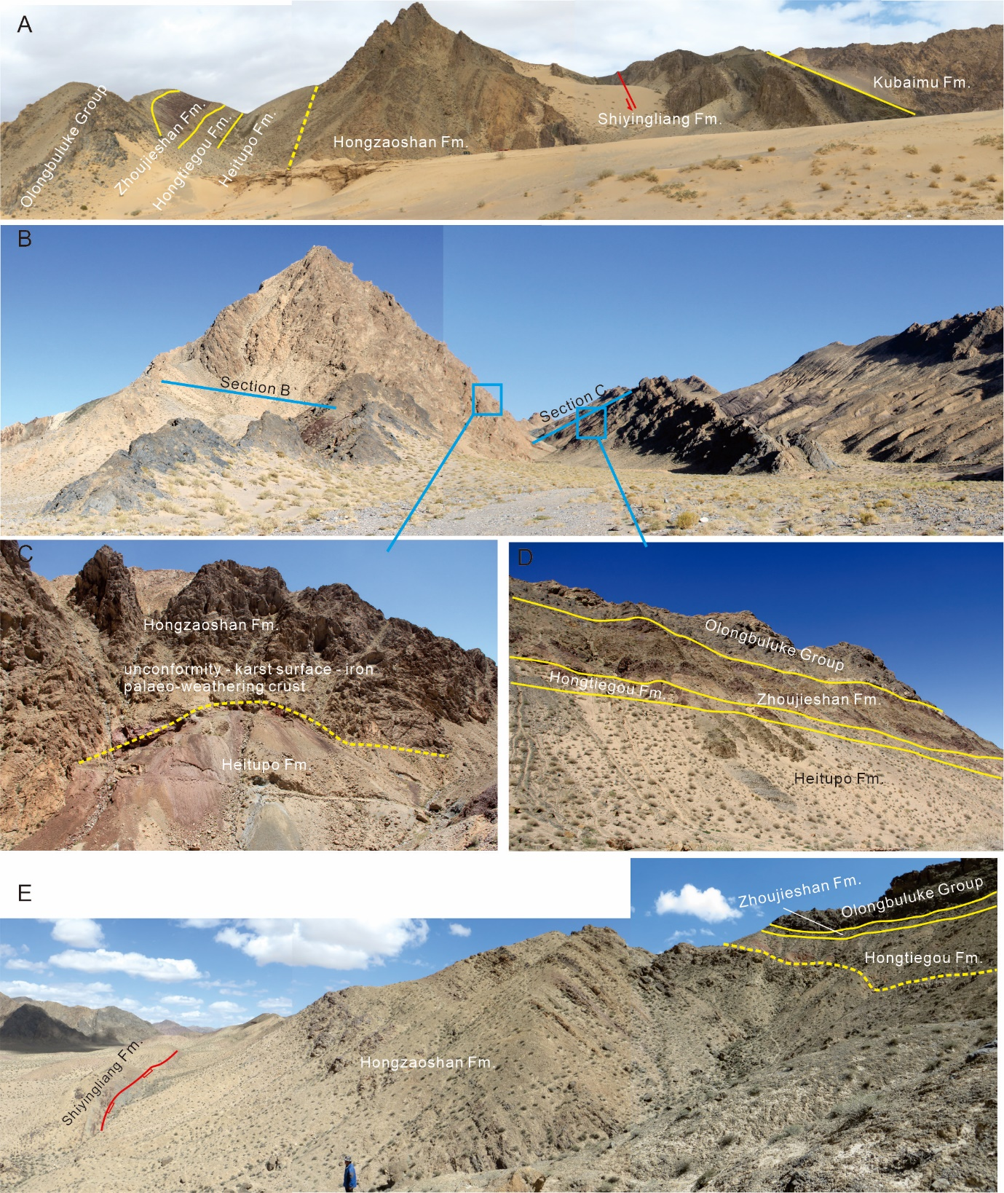

**Figure S2.** Photographs of the representative sections in Quanji block. (A-B) Sections from the Quanjishan area. (C) Hematite filled karst on the top of Hongzaoshan Formation. (D) the upper part of section C. (E) Section E from the Shihuigou area.



**Figure S3**. Photomicrographs of the felsic volcanics from the Hongzaoshan Formation. A. rhyolite with phenocrysts of plagioclase and quartz, embedded in a fine groundmass. B. ignimbrite marked by deformed minerals and lithic fragments. C. lentiform tuff collected from the Quanjishan.

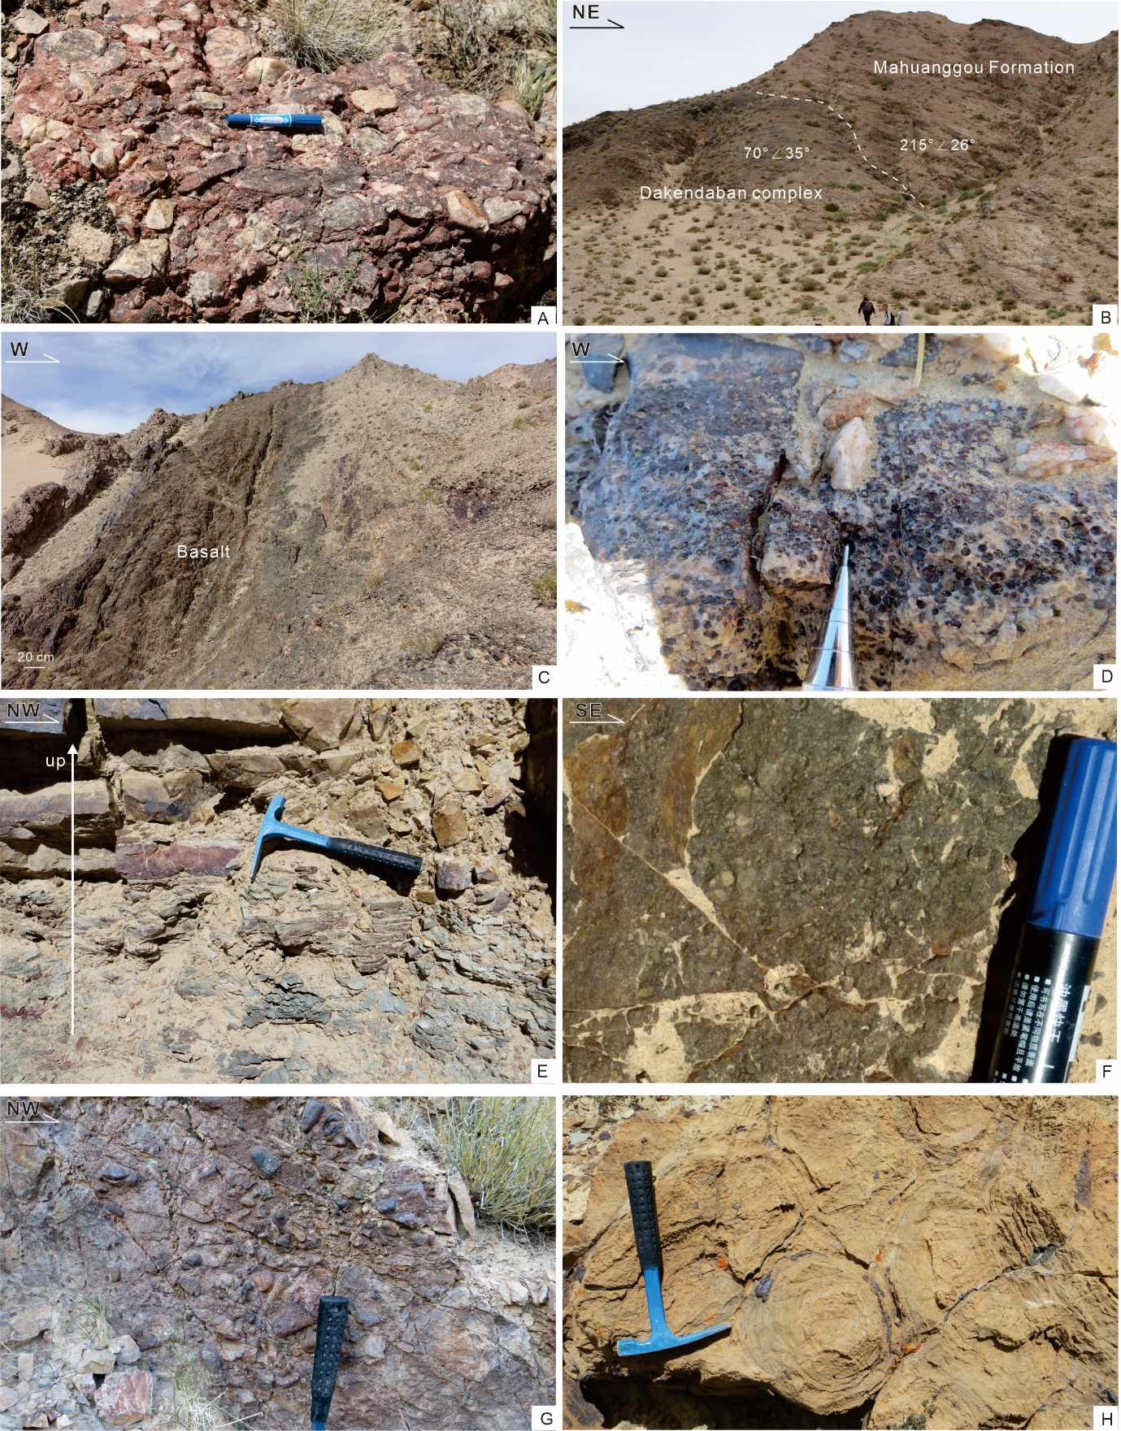

Figure S4. Photographs of the Quanji Group. A. Conglomerate at the base of Mahuanggou Formation, photo taken in Quanjishan. B. The Mahuanggou Formation unconformably overlies crystalline basement, photo taken in Quanjishan. C. Basaltic bed at the base of Shiyingliang Formation, photo taken in Quanjishan. D. Ooidal hematite-rich quartz sandstone at the middle member of the Shiyingliang Formation, photo taken in Shihuigou. E. Lower shale-rich portion grading up to a sandstone-rich upper portion of the lower member of Shiyingliang Formation, photo taken in Olongbuluke. F. Rhyolite within the lower member of the Hongzaoshan Formation, photo taken in Shihuigou. G. Chert and dolostone clasts in the dolostone of middle member of Hongzaoshan Formation, photo taken in Shihuigou. H. Stromatolitic dolostone in the upper member of Hongzaoshan Formation, photo taken in Quanjishan.

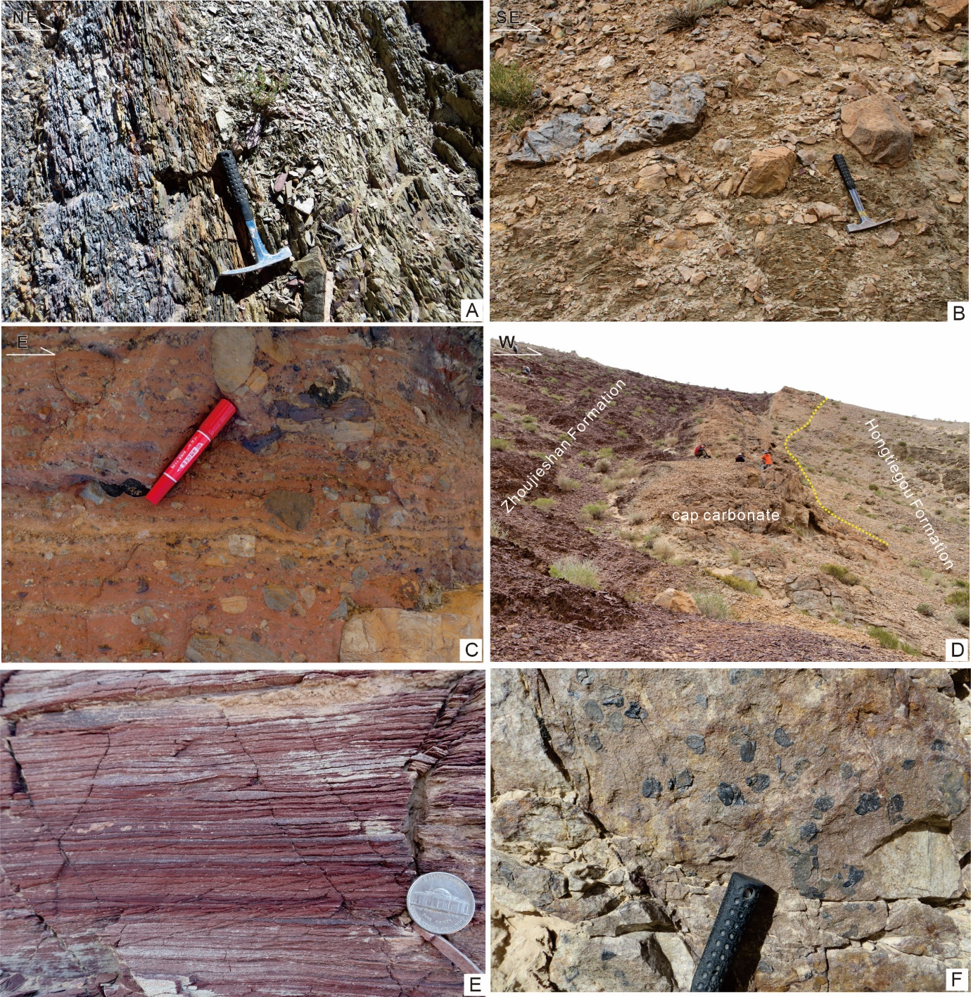

Figure S5. Photographs of the Heitupo Formation, Xiaogaolu and Olongbuluke groups. A. Black carbonaceous shale and greenish-gray mudstone of the Heitupo Formation, photo taken in Quanjishan. B. Dolostone pebbles in laminated greenish muddy matrix at the lower member of the Hongtiegou Formation, photo taken in Quanjishan. C. Clasts in dark red dolomitic matrix at the Hongtiegou Formation, photo taken in Shihuigou. D. The Hongtiegou glacigenic diamictite is overlain by a thick unit of gray dolostone which is considered as a ‘cap carbonate’, photo taken in Quanjishan. E. Reddish thin-laminated siltstone and sandstone of the Zhòujíeshān Formation. F. Dark gray phosphatic and chert concretions at the base of the Olongbuluke Group, photo taken in Quanjishan.



Figure S6. Comparative tectono-stratigraphic time-space chart of Tarim (BGMX, 1993; Xu and others, 2009; Wang and others, 2015a, 2018; Zhang and others, 2019a), Quanji block (BGMS, 1989; Xu and others, 2016; Wang and others, 2015b, 2018; Zhang and others, 2016), southern NCB (Zhao and Deng, 2016; Zhang and others, 2019b), and SCB (Wang and others, 2011; Wang and others, 2015c; Geng and others, 2017). UHPM=high- to ultra-high pressure metamorphic.

1. State Key Laboratory of Continental Dynamics, Department of Geology, Northwest University, Xi’an 710069, P R China

   ** Department of Earth and Planetary Sciences, Yale University, New Haven, CT 06520-8109, USA

   *** Orogen Research Centre of China Geological Survey, Xi’an Center of Geological Survey, China Geological Survey, Xi’an 710054, P R China

   **** College of Earth and Planetary Sciences, University of Chinese Academy of Sciences, Beijing 100049, China

   ***** School of Earth Science, China University of Geosciences, Wuhan 430074, China
2. Corresponding author: chaowang@nwu.edu.cn