9.1 Equation (2) and Equation (3) derivation
La/La* $= \frac{[La]}{3[Pr]-2[Nd]}$ ….(2)
Ce/Ce* $= \frac{[Ce]}{2[Pr]-[Nd]}$….(3)
Assume a linear slope for REE concentration as the atomic number increases. Pr and Nd are known and fixed values. La* and Ce* concentrations are estimates. [La] and [Ce] are measured values.
Ce/Ce*:

 | $[Pr]$ $= \frac{Ce*+[Nd]}{2}$ | (S1)
 | $Ce* = 2[Pr]-[Nd]$ | (S2)
 | Ce/Ce* $= \frac{[Ce]}{2[Pr]-[Nd]}$ | (S3)

La/La*:
 | $Ce* = \frac{La*+[Pr]}{2}$ | (S4)
 | $La* = 2Ce*-[Pr]$ | (S5)
With equation (S2), equation (S5) becomes:
$La* = 2(2[Pr]-[Nd])-[Pr]=3[Pr]-2[Nd]$
La/La* $= \frac{[La]}{3[Pr]-2[Nd]}$

9.2 Supplementary Figures

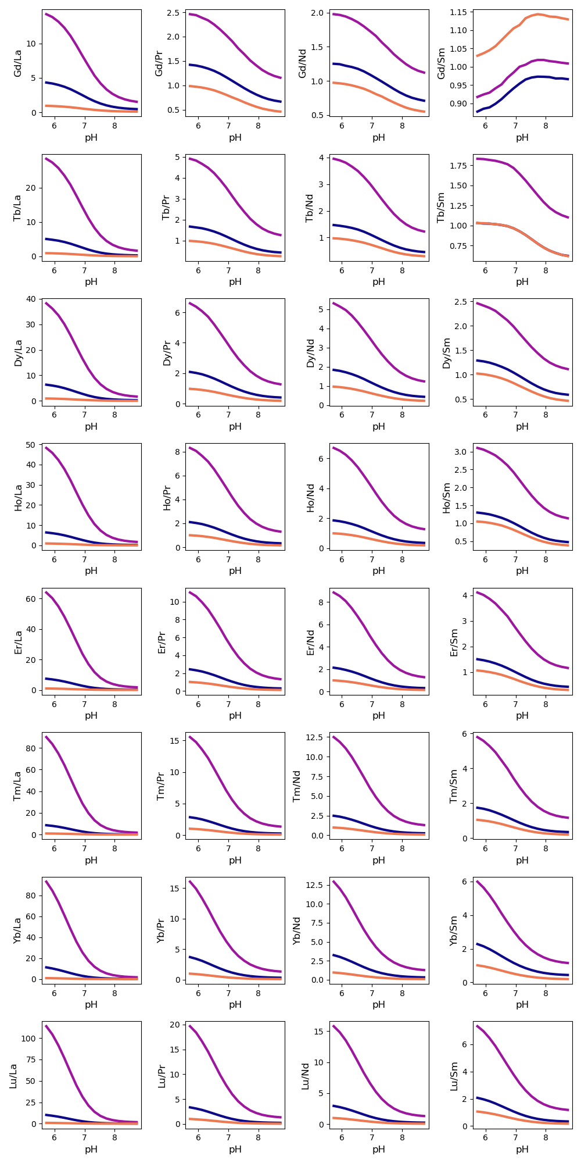
Supplementary Figure 1: HREE/LREE ratios of the REE species in seawater. HREE/LREE ratios are rough indicators of HREE enrichment. However, the ratios depend on individual REEs, so there are slight differences between the ratio values when pH changes. The species correspond to the same colors as those mentioned in Figure 2 (Purple: dicarbonate species; Blue: monocarbonate species; Orange: trivalent ions).

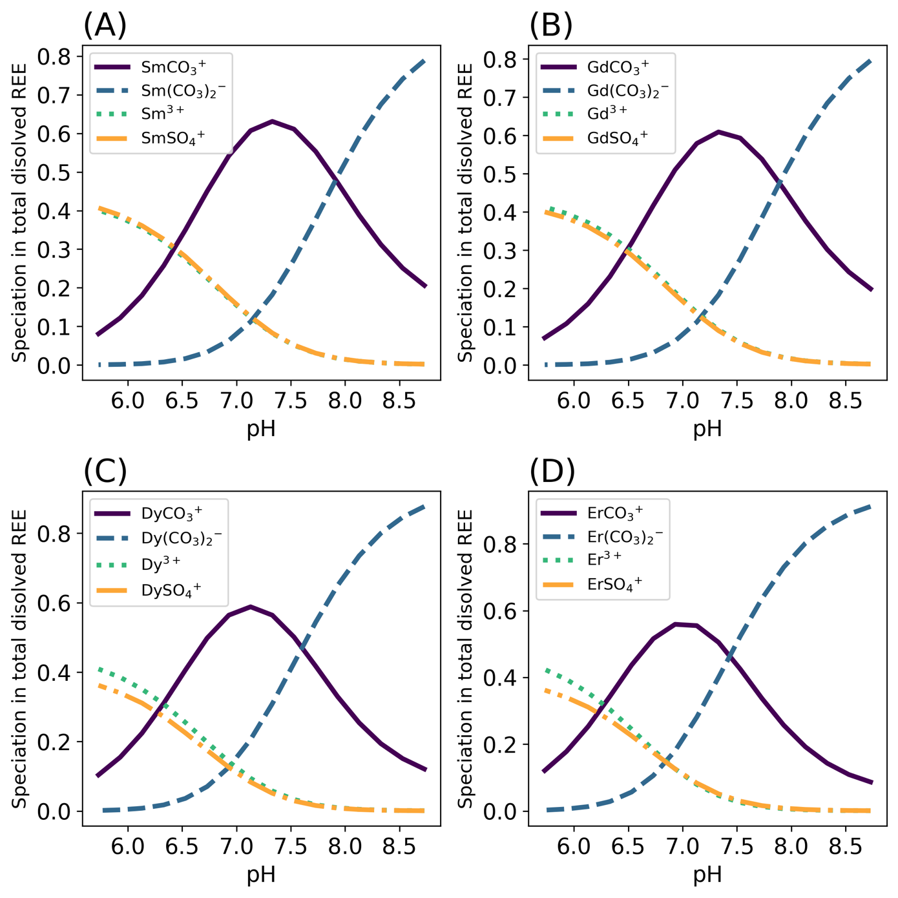
Supplementary Figure 2: Figure 1 with sulfate speciation of the REEs included.
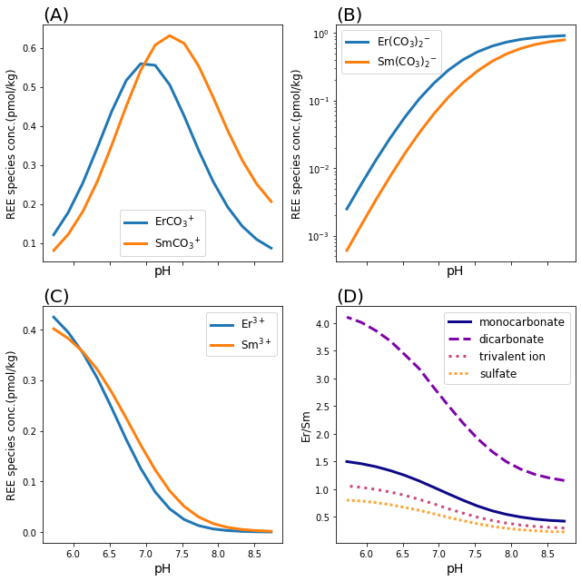
Supplementary Figure 3: Figure 2 with sulfate speciation of the REEs included.

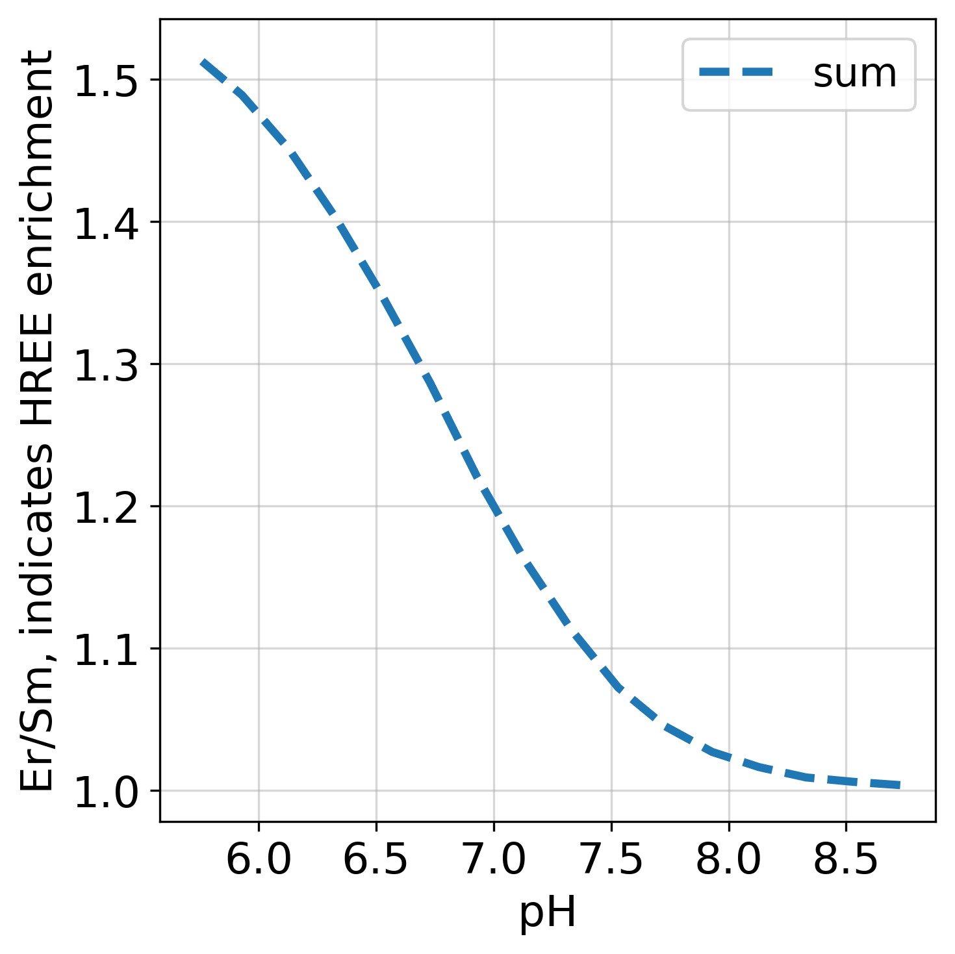
Supplementary Figure 4: The sum of the combined Er/Sm ratio of (a), (b), and (c) in Figure 2.

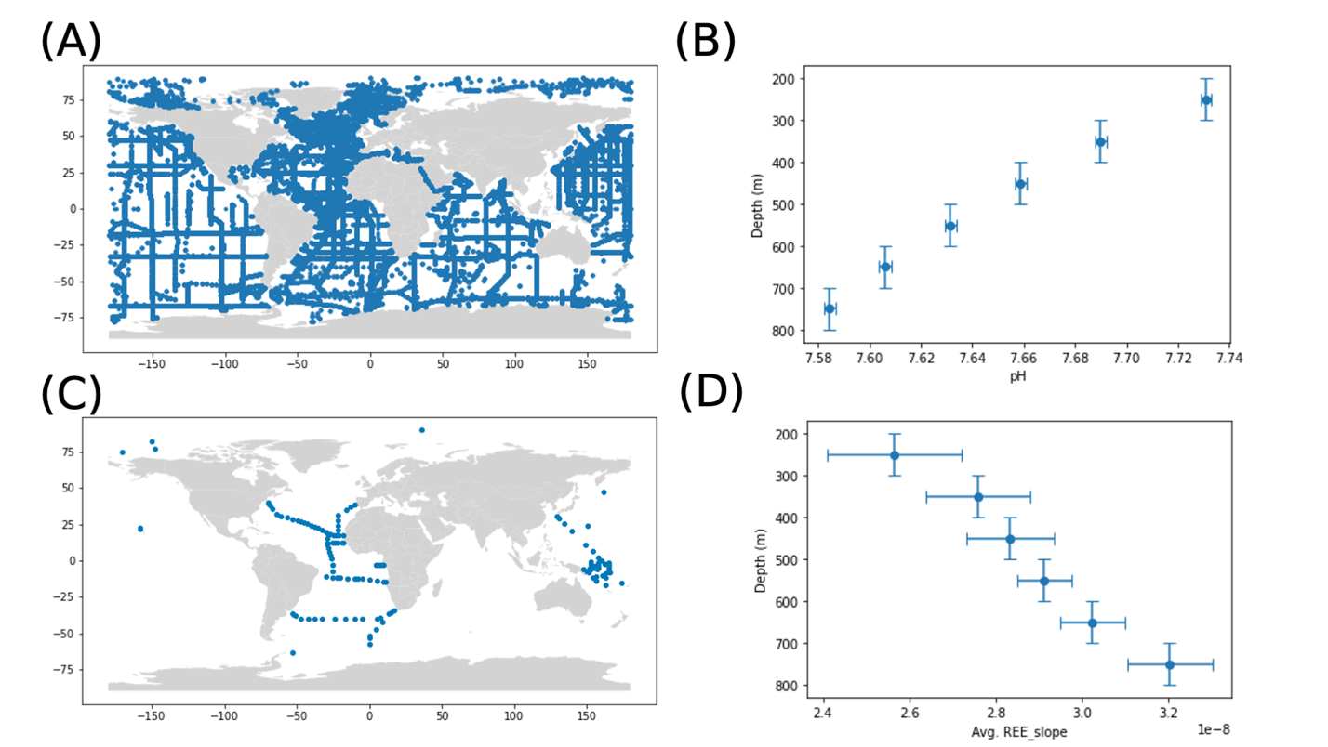
Supplementary Figure 5: The samples of modern seawater pH and REE concentration measurements that were used in the calibration for the REE-pH proxy in Figure 3. (a) The location of the pH samples from GLODAPv2 database plotted on a world map (Olsen et al., 2016; Key et al., 2015). (b) The global pH average of every 100m between 200-800m depth. The x-axis error bars indicate the 2σ standard error for the mean pH, and the y-axis error bars are the 100m range of depth. (c) The location of REE concentrations samples from GEOTRACES plotted on a world map (GEOTRACES Intermediate Data Product Group, 2021). (d) The REE slope average of every 100m between 200-800m depth. The x-axis error bars indicate the 2σ standard error for the mean REE slope, and the y-axis error bars are the 100m range of depth.

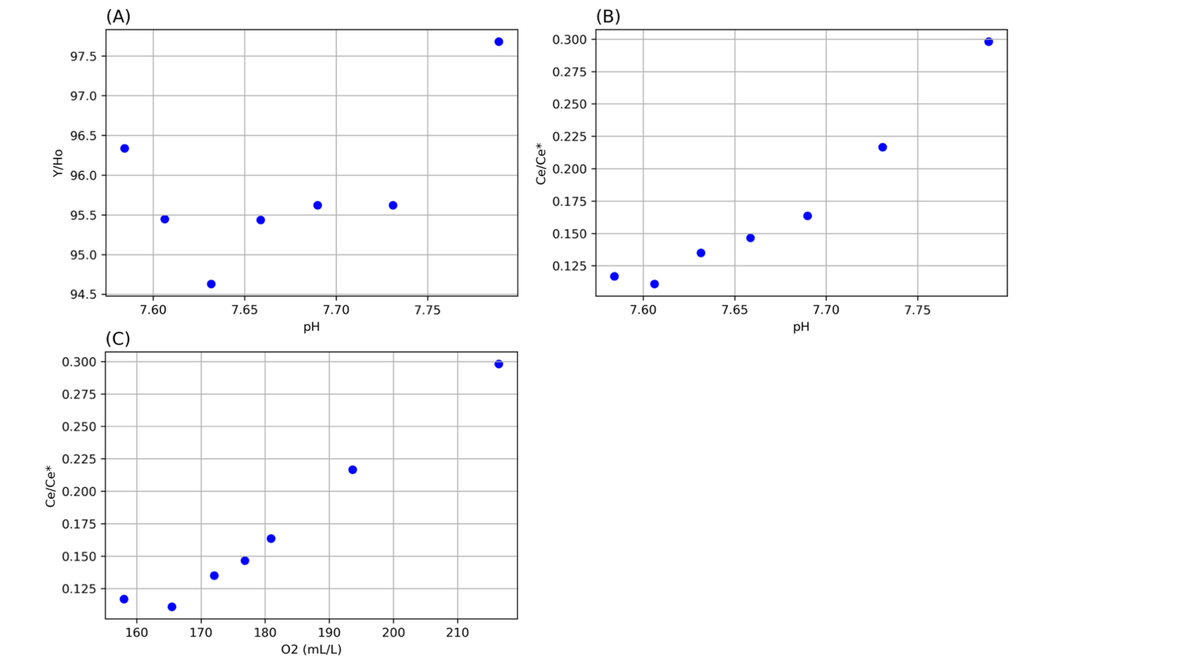
Supplementary Figure 6: The correlation between the (a) Y/Ho and pH (b) between Cerium anomaly and pH at the same depth range of seawater for the REE-pH proxy calibration in Figure 3 (c) Ce anomaly and dissolved oxygen in seawater.

