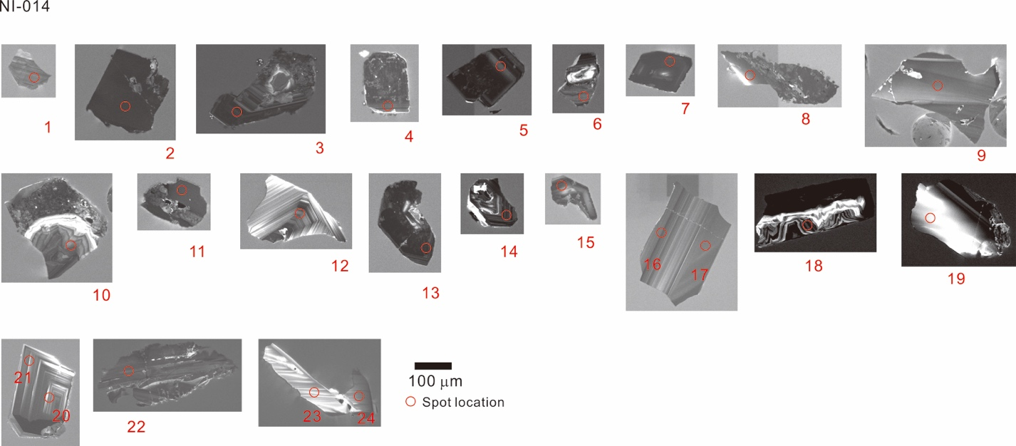
Fig. S1. Cathodoluminescence images of the zircons from sample NI-014. The spot number corresponds to the analysis in table S3 and spot location.

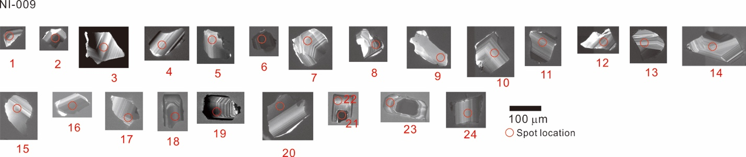
Fig. S2. Cathodoluminescence images of the zircons from sample NI-009. The spot number corresponds to the analysis in table S3 and spot location.

