Supplementary Material for "One million years of climate-driven rock uplift rate variation on the Wasatch Fault revealed by fluvial topography"

Adam G G Smith^{1, 2*}, Matthew Fox², Jeffrey R Moore³, Scott R Miller³, Liran Goren⁴, Matthew C Morriss⁵, and Andrew Carter^{1, 2}

¹ Department of Earth & Planetary Science Birkbeck, University of London, Malet St., London WC1E 7HX, UK
² London Geochronology Centre, University College London, University of London, London, WC1E 6BT, UK
³ Department of Geology and Geophysics, University of Utah, Salt Lake City, Utah, U.S.A.
⁴ Earth and Environmental Sciences, Ben-Gurion University of the Negev, 84105 Beer Sheva, Israel
⁵Utah Geological Survey, 1594 West North Temple, Suite 3110, Salt Lake City, Utah 84116

*Corresponding author
Email: adam.smith.20@ucl.ac.uk

Introduction
The following supplementary material provides results from a synthetic test of the method used to infer the erodibility, K, through time from river profiles. These tests demonstrate the pattern of inferred K that we expect to observe if either rock uplift rate or erodibility is variable through time. Additionally, we provide two inferred rock uplift rate histories that demonstrate our model sensitivity to errors associated with the calibration. We also present a result of model sensitivity to concavity index.

Text S1. Synthetic Test - inferring erodibility through time

We use the method of Goren (2016) to infer erodibility through time from the river profiles of the Wasatch. We show that the variations in the inferred erodibility are different to the variations in inferred rock uplift rate. However, it is difficult to determine which scenario is truly creating the variations in channel steepness in the river profiles of the Wasatch; pseudo-sinusoidal variations in rock uplift rate, or spiky, periodic increases in erodibility. We have good evidence that the former scenario is more likely. The estimated erodibility from cosmogenic nuclides and from the river profile inversion are similar, so erodibility has been similar on both medium and long timescales, suggesting changes in rock uplift rate drive variation in the river profile. However, it is important to further validate this with synthetic tests.

We use the FastScape algorithm (Braun and Willett, 2013) to simulate a river profile under different conditions. In the first scenario, rock uplift oscillates and the erodibility is constant. In the second, the erodibility oscillates and rock uplift rate is constant. We then extract the erodibility through time for these two synthetic profiles, to observe how the inferred erodibility differs when rock uplift rate is variable, compared to when erodibility is variable. The results of these synthetic tests are shown in Figure 1.

The inferred erodibilities for the two synthetic profiles are very different (Figure 1 E and F). When the erodibility is variable through time, the inferred erodibility closely matches this variation, recovering the input erodibility well. However, when the rock uplift rate is variable, the inferred erodibility is spiky, with short wavelength increases in erodibility corresponding to flat portions of the profile where the rock uplift rate is close to 0. The inferred erodibility from the variable uplift rate test shows similar patterns to the erodibility inferred from the rivers in the Wasatch. We therefore suggest that it is more likely that rock uplift rate variation is responsible for changes in channel steepness in the Wasatch.

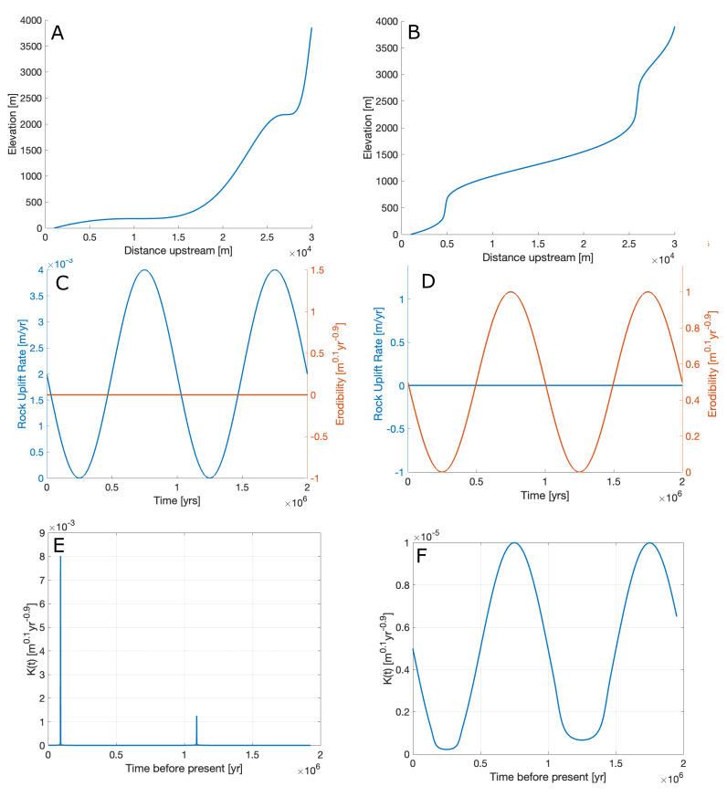
Figure S 1. Results of synthetic testing, with the variable uplift scenario shown on the left, and variable erodibility shown on the right. A. Synthetic river profile created using the FastScape algorithm with an oscillating rock uplift rate and constant erodibility B. Synthetic river profile created using the FastScape algorithm with an oscillating erodibility, but constant uplift rate. C. The input rock uplift rate and erodibility used to produce the profile in A. D. The input rock uplift rate and erodibility used to produce the river profile in B. E. The inferred erodibility from the river profile in A. F. The inferred erodibility from the river profile in B. When the erodibility is changing, the inferred erodibility is very similar to the actual erodibility. However, when uplift changes, the erodibility is very spiky. Given the patterns extracted from the Wasatch, it is likely that a change in rock uplift rate is driving variation in channel steepness index.

Text S2. Sensitivity of rock uplift rate history to calibration

Our inferred rock uplift rate history is calibrated by estimating a value for the erodibility, K, so that it matches the exhumation rate predicted from thermochronometry data and modelling (Armstrong et al., 2003; Ehlers et al., 2003). To model the data, Armstrong et al. (2003) assumed that the Wasatch uplifted around a structural hinge located somewhere to the east of the fault trace. The best fitting model to the thermochronometry data suggests that, from 5 Ma to the present, the Wasatch has uplifted at a rate of 0.8 km/Ma around a hinge, 25km from the fault (Ehlers et al., 2003). Hence, our inferred rock uplift rate histories from the river networks (Figure 10) were calculated using this rock uplift rate.

However, Armstrong et al. (2003) provide a range of acceptable models that fit the AHe data, and suggest that for a structural hinge between 20 and 40 km, rock uplift rates on the Wasatch fault are likely between 0.6-0.9 km/Ma. To test the sensitivity of our analysis to this range, we calibrate the rock uplift rate histories using these end member values (Figure 2). In each case, the two peaks in rock uplift rate shifts, but neither of the end member calibrations show a shift of more than 50 ka. This represents less than half the wavelength of the observed variation, and is within error of some of the age estimates for the pluvial lake highstands (Oviatt et al., 1999). In both of the rock uplift rate histories, there are still two distinct peaks in rock uplift over the last 1 Ma.

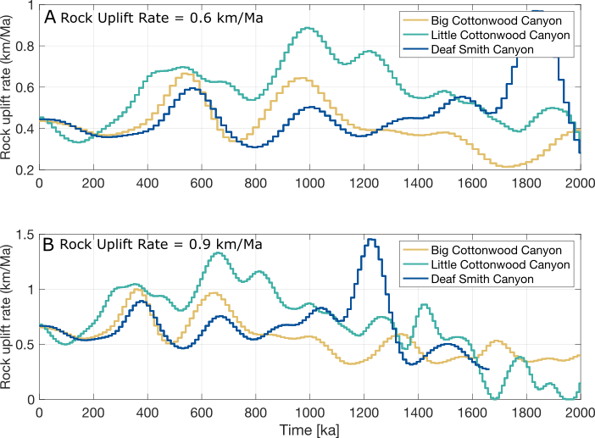
Figure S 2. Two sets of inferred rock uplift rate histories calibrated using different K values so that the average rock uplift rate predicted is either 0.6 km/Ma or 0.9 km/Ma based on estimates from Ehlers et al., (2003) A. Rock uplift rate histories calibrated to 0.6 km/Ma. There are peaks around 550 ka and 900 ka, aporoximately 100 ka after the solution presented in figure 10. Little Cottonwood Canyon however appears to show an increase in rock uplift rates at around 400 ka, similar to the first peak in figure 11. B. Rock uplift rate histories calibrated to 0.9 km/Ma. The two peaks are at a similar time to the two peaks in figure 10, but occur approximately 50 ka earlier. Both A and B show a shift in the peaks, but neither solution goes further than half a wavelength of each peak.

Text S3 – Sensitivity to the concavity index
The concavity index or m/n describes the concavity of a river long profile. A value for the concavity index is required in order to calculate the channel steepness index (Equation 5), χ (Equation 7), and the response time, τ (Equation 13), used to recover the rock uplift rate history from the river networks. It has been shown that spatial patterns of channel steepness index can be altered by changing the value of the concavity index (Gailleton et al., 2021), and whilst not explicitly tested by Goren et al. (2014), they do show that rock uplift rate histories inferred from river networks are slightly different at different concavity index values.

Ideally, we would constrain a value for the concavity index prior to analysis, however, in our study area this is not possible. There is obvious transience in the network, evident as knickpoints, and so performing a slope-area analysis for the concavity index is inappropriate. Similarly, due to spatial gradients in rock uplift that exist, it is not appropriate to constrain the concavity index using a method based on χ (e.g. Mudd et al., 2014). Instead, we use an appropriate value for the concavity index, 0.45, that has been widely employed in similar tectonic settings.

To test the sensitivity of our results to variation in concavity index, we run our inverse scheme to recover rock uplift rate for Big Cottonwood Canyon with three different values for the concavity, 0.3, 0.45 and 0.6. The inversions are run with the same value for the smoothing parameter, $α$, and the same number of timesteps. Each history is then calibrated to the same thermochronology constraint detailed in the main text (Section 3.3). The results are shown in figure S3.

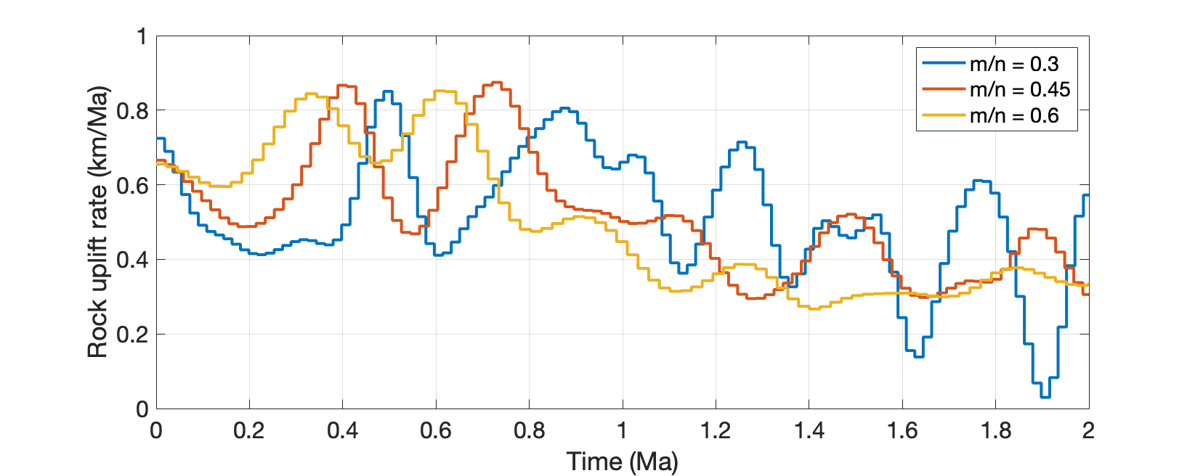
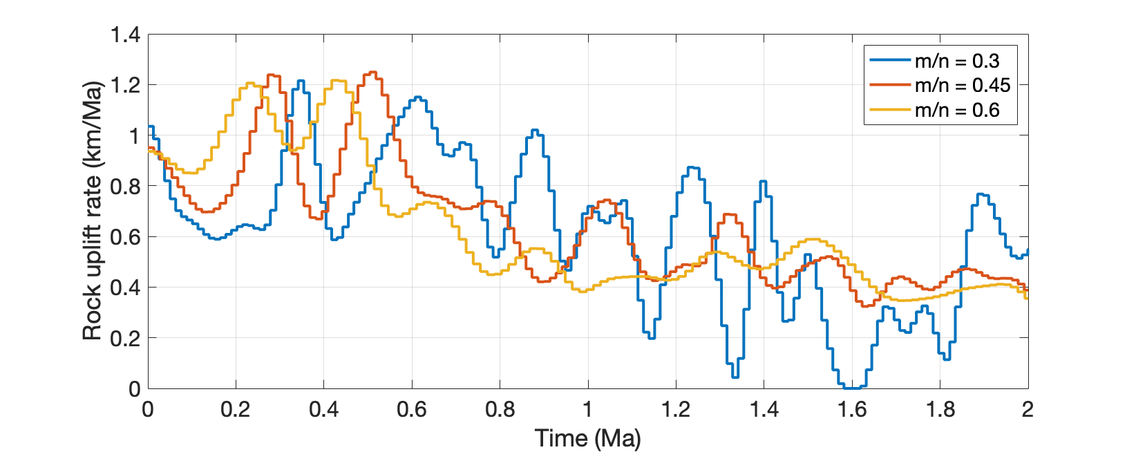
Figure S3. Rock uplift rate histories inferred from the river network of Big Cottonwood Canyon, assuming different values for the concavity index.
Changing the concavity index does have an impact on the recovered rock uplift rate histories, however, in the portion of the rock uplift rate history that we are interested in (between 0-1 Ma), these differences are not so large as to significantly alter our conclusions. Firstly, each history recovers an upturn in rock uplift rate towards the present, initiating at around 0.2 Ma. Each history also recovers two peaks in rock uplift rate between 1 Ma and 0.3 Ma. The positions of these peaks are slightly different depending on the m/n value, although they are not so different that the pacing of oscillation in rock uplift rate is significantly different. For instance, the time period between the two peaks for the history created using an m/n of 0.3 is approximately 0.35 Ma, whereas the time period at an m/n of 0.6 is 0.25 Ma. This difference is not big enough to change the interpretations of our rock uplift rate history. The pacing of each history is still approximately in tune with lake filling and emptying cycles, as opposed to having a wavelength short enough to represent 100 ka climatic cycles, or long enough to be associated with the Mid-Pleistocene transition at 800 ka.

Another difference in the histories is that the amplitude of change in rock uplift rate is slightly smaller at higher values of m/n. Interestingly however, the maximum rock uplift rate values are all similar.

References
Armstrong, P.A., Ehlers, T.A., Chapman, D.S., Farley, K.A., and Kamp, P.J.J., 2003, Exhumation of the central Wasatch Mountains, Utah: 1. Patterns and timing of exhumation deduced from low-temperature thermochronology data.: Journal of Geophysical Research: Solid Earth, v. 108, doi:10.1029/2001JB001708.
Braun, J., and Willett, S.D., 2013, A very efficient O(n), implicit and parallel method to solve the stream power equation governing fluvial incision and landscape evolution: Geomorphology, v. 180–181, p. 170–179, doi:10.1016/j.geomorph.2012.10.008.
Ehlers, T.A., Willett, S.D., Armstrong, P.A., and Chapman, D.S., 2003, Exhumation of the central Wasatch Mountains, Utah: 2. Thermokinematic model of exhumation, erosion, and thermochronometer interpretation: Journal of Geophysical Research: Solid Earth, v. 108, doi:10.1029/2001JB001723.
Gailleton, B., Mudd, S.M., Clubb, F.J., Grieve, S.W.D., and Hurst, M.D., 2021, Impact of Changing Concavity Indices on Channel Steepness and Divide Migration Metrics: Journal of Geophysical Research: Earth Surface, v. 126, doi:10.1029/2020JF006060.
Goren, L., 2016, A theoretical model for fluvial channel response time during time-dependent climatic and tectonic forcing and its inverse applications: Geophysical Research Letters, v. 43, p. 10,753-10,763, doi:10.1002/2016GL070451.
Goren, L., Fox, M., and Willett, S.D., 2014, Tectonics from fluvial topography using formal linear inversion: Theory and applications to the Inyo Mountains, California: Journal of Geophysical Research: Earth Surface, v. 119, p. 1651–1681, doi:10.1002/2014JF003079.
Mudd, S.M., Attal, M., Milodowski, D.T., Grieve, S.W.D., and Valters, D.A., 2014, A statistical framework to quantify spatial variation in channel gradients using the integral method of channel profile analysis: Journal of Geophysical Research: Earth Surface, v. 119, p. 138–152, doi:10.1002/2013JF002981.
Oviatt, C.G., Thompson, R.S., Kaufman, D.S., Bright, J., and Forester, R.M., 1999, Reinterpretation of the Burmester Core, Bonneville Basin, Utah: Quaternary Research, v. 52, p. 180–184, doi:10.1006/qres.1999.2058.

