Supplemental Materials for

The carbon isotopic composition of Archean kerogen and its resilience through the rock cycle
Sarah S. Zeichner^{1*}, Woodward W. Fischer¹, Noam Lotem¹, Kelsey R. Moore^{1,2}, Joshua E. Goldford¹, John M. Eiler¹
*corresponding author; Email: szeichner@caltech.edu

Materials and Methods

Maturation model
The isotopic box model presented here offers a simplified interpretation of the chemical and resulting isotopic changes that will occur through catagenesis/metagenesis and metamorphism where the major changes in the isotopic composition of C within these two alteration regimes are driven by homolytic cleavage, and exchange with dissolved inorganic carbon (DIC) in metamorphic fluids, respectively. The spreadsheet with the model parts can be found in a supplementary spreadsheet (S. S. Zeichner, 2023), along with an additional spreadsheet that models decarboxylation reactions that occur in diagenesis, as described in the next section.
The model requires interconversion between delta values, isotope ratio (R values), and fractional abundances (F values). We can interconvert between R and F using the following equation:
$$F= \frac{R}{1+R} (eq. S1)$$

Diagenesis
Changes in the isotopic composition of organic matter during diagenesis could be caused by either selective preservation of certain compounds, or condensation of compounds through reactions that remove functional groups with kinetic isotope effects. In particular, as noted in the Main text, diagenetic removal of carbon atoms from the system is driven primarily by decarboxylation, which removes both carbons and oxygens and thus lowers the O/C ratio as captured by the van Krevelin diagram.
To estimate how much decarboxylation is capable of shifting δ¹³C_{org}, we modeled the effect of decarboxylation on a model compound— decanoic acid—which we chose as a representation of the average O/C ratio in immature organic matter. While the relative contribution/preservation of sugars, lipids, and proteins deriving from biomass to deposited organic matter is still not fully understood, we chose relative amounts of 0.2, 0.6, and 0.2, respectively, informed by amounts reported in Burdige (2007). These amounts not only result in an O/C ratio of 0.2, which is consistent with the starting point of immature OM in the Van Krevelin diagram, but also result in an average N/C ratio of 0.0667, which is consistent with the N/C ratio of immature organic matter reported by Wu et al., 2004.
It has been demonstrated in the literature that fatty acids like decanoic acid have intramolecular isotopic variation: The carboxyl group δ¹³C_{VPDB} value is higher than the δ¹³C_{VPDB} values of the other groups (-13‰ versus ~-27‰ for measurements of modern E. coli; Monson and Hayes, 1980). We therefore started out with the carboxyl site having δ¹³C_{VPDB} = -13‰ and the other 9 sites having δ¹³C_{VPDB} values of -37‰ (consistent with lower δ¹³C_{VPDB} values of Archean samples, as these values result a molecular average δ¹³C_{VPDB} of -34.6‰).
We iteratively modeled the decarboxylation of decanoic acid with model steps of 0.01 moles out of 1 total unreacted moles of fatty acid, where each step loses 2 oxygens for each C (as is the case with decarboxylation). We modeled a Rayleigh distillation process on the R value, which we converted from delta values using the following equation:

$$R = \left(\left(\frac{}{1000}\right)+ 1\right)+R_{VPDB }(eq S2)$$

where R_{VDPB}=0.01118. R values following the Rayleigh distillation process for each decarboxylation step were computed as follows:

$$R_{after} = R_{before} *{f_{m}}^{\left(-1\right)} (eq S3)$$

where the f_{m} is the fraction of molecules unreacted, and α is the kinetic isotope effect (KIE) of decarboxylation. Here, we applied an α value = 0.97 (¹³k/¹²k) as reported in Marlier and O’Leary (1984) and Lewis et al. (1993). We converted the R_{after} for the site into an F value (eq. S1) and then used that F value to compute the average F value of the total organic carbons in the system, considering the instantaneous fraction of carboxyl sites relative to all carbons in the system (of both the decanoic acid and decarboxylated decanoic acid, i.e., nonane). The fraction of carboxyl sites (f_{c}) was calculated based on f_{m} as follows:

$$f_{c }=\frac{f_{m }*\frac{1}{10}}{1-\left(1-f_{m }\right)*\frac{1}{10}} (eq S4)$$

We assumed that the average isotopic composition of neutral carbons remains constant during this reaction due to mass balance (although we note that this is a simplification, as decarboxylation reactions also isotopically discriminate against ¹³C of the neutral carbon bonded to a carboxyl group). However, as the bonded neutral carbon does not leave the system, but is only transferred from the decanoic acid pool to the nonane pool, the average composition of neutral carbons in the system is preserved.
Finally, we computed an F value for the decanoic acid + nonane pool for each step, as follows:

$F= F_{after}*f_{c }+F_{alkane}*\left(1-f_{c }\right) (eq S5)$

where F_{after} is the R_{after} value that was converted into an F value following equation S3, and F_{alkane} is the fractional abundance of the original non carboxyl group carbon (i.e., δ¹³C_{VPDB} = -37‰). We converted the F value into an R value, and then into its δ¹³C_{VPDB} value (assuming R_{VDPB}=0.01118 as noted above) to be able to understand how the isotope ratio would change over time within the context of a widely accepted international reference frame (VPDB).
We performed the above steps until the O/C ratio = 0.1, which is the approximate value where the O/C ratio of organic matter stops changing within the van Krevelin diagram. Our diagenesis model suggests that decarboxylation drives a change in the isotopic composition of OM that is within the range that has been documented through empirical studies of isotopic change through diagenesis (see Main Text). Following diagenesis, catagenesis becomes the dominant phase of organic matter degradation, where elemental changes become mainly driven by the loss of H from the system.

Catagenesis
We use the final isotopic composition of our simplified organic matter from the diagenesis model as the starting point of the catagenesis model. The catagenesis model idealizes the maturation of C through the oil as being largely driven by homolytic cleavage, or the production of natural gas (Xie et al., 2021).
Our simplied model of Type II kerogen begins with an H/C ratio of 1.2 (Ungerer et al., 2015). We iteratively model the homolytic cleavage by assuming that each cracking reaction forms only methane, where 1 C and 4 H get removed at each reaction progress step (we note that in natural systems a mixture of methane, ethane, propane, and higher order hydrocarbons can be produced upon each cracking reaction and present results from these calculations in supplemental fig 2 (Xie et al., 2021). For each step, we convert the initial δ¹³C_{org} of the immature kerogen pool to its R value (eqn S2).
We assume that the reactant carbon pool undergoes Rayleigh distillation, following eqn S3. We apply a α values of = 0.975±0.010 (¹³k/¹²k) as reported in (Tang et al., 2000; Xie et al., 2021). Finally, we convert the R value into its delta value as described above.
We iterate following the above steps until the H/C ratio of our organic matter pool = 0.1 in order to connect the end of our diagenesis model with the beginning of our metamorphism model, presented next. We also include data from Des Marais, 1997, which demonstrates a very similar result between our model and the prior empirical fit presented by Des Marais for the range of H/C values included in that paper.

Metamorphism
To model the metamorphic exchange processes described in the main text, we assume that our organic matter starts with a δ¹³C_{org} value equal to the final composition at the end of the catagenesis model (average -26‰ across the model runs), and exchanges with an infinitely large pool of dissolved inorganic carbon (δ¹³C = -6 to 0‰), where the organic carbon is expected to maximally achieve a δ¹³C of -6‰ for a δ¹³C_{carbonate} = 0‰ as described in the text. As a result, this part of the model simply tracks the mixing of carbons with the original δ¹³C value of organic matter, with the fully equilibrated graphitic end member (δ¹³C = -6‰), while the reaction progress represents the fraction of carbon that underwent isotopic exchange with DIC.
For each reaction step, we convert the starting δ¹³C values to R and then to F values (eq. S1), and compute the isotopic composition of the mixed product as follows:

$$F_{graphite}= f_{unreacted}*F_{organic }+ f_{reacted}*F_{equil, graphite }(eq S6)$$

The computed F_{graphite} values are then converted into R and δ¹³C values.

Supplementary Text

Studies of Archean biomarkers, microfossils, and associated lithology
Along with the study of their carbon isotope records, Archean rocks have been investigated for potential sedimentological evidence of life as well as organic biomarker molecules. Putative stromatolites, carbonaceous spheroids, and biofilms have been identified in rocks of ~3.35 Gya (Strelley Pool formation of the Warrawoona group; Schopf, 1993, 2006; Marshall et al., 2007; Allwood et al., 2009), but the biogenicity of these structures remain debated by sedimentologists and paleontologists (for example, Brasier et al., 2002). A study of younger Archean rocks proposed the presence of organic biomarker compounds in 2.78-2.45 Gya rocks (that is, steranes and hopanes; Brocks et al., 2003a), which would provide key evidence for the rise of oxygenic photosynthesis and a strikingly early evolution of eukaryotes. A later study failed to replicate these results on a cleanly drilled core from a different, but nearby location (French et al., 2015). The earliest definitive molecular biomarkers are late Paleoproterozoic in age from the Barney Creek Fm (Brocks et al., 2005; Lepot, 2020; Love and Zumberge, 2021).
Biosignatures from Archean and Proterozoic basins are typically preserved in three major classes of sedimentary rocks: carbonate, chert, and shale or mudstone. Each of these rock types represents different depositional environments and taphonomic windows, both of which control preservation potential through the balancing act between degradation and preservation of organic compounds. Most of the best-preserved Precambrian microbial body fossils are preserved in chert, a crypto- to microcrystalline quartz that is thought to have precipitated rapidly in shallow marine or hydrothermal systems to preserve the fine detail of trapped cells as well as the kerogenous material from their cell walls and EPS. As a result of this rapid precipitation, cells trapped in chert become encased in micro- to nanoscopic minerals smaller than a cell before extensive degradation can occur, allowing for the retention of cell shapes and preventing extensive degradation of the organic compounds. Most examples of body fossils are found in formations that post-date the GOE (Strauss & Moore, 1992). However, pre-GOE chert deposits from either potential hydrothermal settings (Fig Tree Formation; Onverwacht Group) or marine settings (Hamersley Group, Pongola Supergroup; Strelley Pool Chert; Panorama Formation; Apex Chert; Dresser Formation; Towers Formation; Pongola Supergroup; Donimalai Formation; Tumbiana Formation; Hamersley Group; Turee Creek Formation; Lime Acres Formation; Gamohaan Group; table S1) preserved clots of organic material as well as organic-rich microbial laminations. Some of these (for example, Gamohaan Group, Lime Acres Formation; Transvaal Basin; Turee Creek Group; Donimalai Formation) contain structures interpreted as putative microfossils (Altermann & Schopf, 1995; Altermann & Wotherspoon, 1995; Barlow & Van Kranendonk, 2018; Czaja et al., 2016; Fadel et al., 2017; Fischer et al., 2009; Gandin et al., 2005; Johnson et al., 2003; Klein et al., 1987; Rasmussen & Muhling, 2023; Venkatachala et al., 1990; Waldbauer et al., 2009).
Carbonate deposits are frequently both spatially and temporally linked to chert in the Precambrian rock record. Many of the biosignature-hosting chert deposits occur as chert layers, nodules, and lenses within carbonate strata. In some of these deposits, microbial structures like stromatolites are comprised of alternating layers of chert and carbonate (Altermann & Schopf, 1995; Altermann & Wotherspoon, 1995; Czaja et al., 2016; Fischer et al., 2009; Flannery & Walter, 2012; Gandin et al., 2005; Johnson et al., 2003; Klein et al., 1987; Rivera & Sumner, 2014; Wright & Altermann, 2000). Like chert, many of these carbonates are finely crystalline and are thought to have precipitated relatively rapidly. As a result of this rapid and fine crystalline precipitation, they also preserve OM and microbial structures exceptionally well (for example, Dresser Formation, Pongola Supergroup, Tumbiana Formation, Turee Creek, Lime Acres Formation, Gamohaan Group; table S1). Unlike chert, however, actual body fossils are rarely found in carbonates. These biosignature-preserving chert and carbonate strata formed most typically in shallow marine environments.
Shale and mudstone differ from chert and carbonate in several key ways. First, shale and mudstone from the Proterozoic and Archean may have formed in any number of environments from lagoons and lakes to deep marine environments. Additionally, the minerals that comprise these deposits are not predominantly comprised of authigenic precipitates. Instead, these deposits formed when mud, clay, and silt-sized sediments settled from suspension and were deposited and accumulated within low energy environments. Still, the small particle sizes of these sediments and the well-documented propensity for clay minerals to bind to functional groups of OM (Droppo et al., 1997; Hemingway et al., 2019; Keil et al., 1994; Keil & Mayer, 2014; Lamb et al., 2020; Maggi, 2005; Mayer, 1994; Zeichner et al., 2021) can result in the trapping and binding of OM within shale and mudstone. In cases where the deposits formed in shallow lagoonal or marine settings, microbial communities that formed mats in these environments were preserved in the form of microbially laminated layers containing OM (for example, Moodies, Mozaan and Hamersley Groups; table S1). For these cases, the OM would have been subject to cycles of production, alteration, and degradation similar to the OM preserved in chert and carbonate. In the case of deeper water deposits such as facies within the Moodies and Mozaan Groups (table S1), it was more frequently the case that clay minerals bound to OM at one point in the transportation process and carried that OM to the sediment-water interface where it was deposited and preserved. The OM preserved in these deeper deposits, therefore, could represent any number of organic compounds produced by any number of organisms that lived either planktonically or in benthic mats and biofilms. Additionally, this OM likely experienced a range of degradation and alteration processes not only over the course of transportation but also after deposition where sediment-dwelling heterotrophs would have utilized the OM delivered to these environments as a source of reduced carbon. As is the case with chert- and carbonate-preserved OM, all of these degradation and preservation processes must be considered when interpreting the OM preserved in shale and mudstone. Several examples of organic-rich body fossils were preserved in shale deposits during the Proterozoic, but these all post-date the GOE and are thought to represent early eukaryotes including acritarchs and algae (Porter, 2004; Knoll et al., 2006; Javaux et al., 2010; Cohen and Macdonald, 2015). For the purposes of this paper, we will focus on measurements of carbonaceous matter in pre-GOE deposits but not fossils, especially because the processes that drive the preservation of OM in sediments may be distinct from the processes that preserve fossils (Wiemann et al., 2020).

Additional notes on the isotope effects of diagenetic reactions
Reactions such as de-amination and sulfurization have been demonstrated and presented by models (for example, (Ungerer et al., 2015) as changing the chemical composition of immature OM during diagenesis. However, these reactions do not affect the number of carbon atoms within the system itself and so the isotope effects on the isotopic composition of residual carbon are likely to be negligible. For instance, sulfurization seems to have little effect on the overall δ¹³C within average OM composition (although it may introduce site-specific isotope effects for the specific atoms undergoing sulfurization reactions; Schouten et al., 1995; Putschew et al., 1998; Rosenberg et al., 2018). Deamination reactions impart quantifiable isotope effects on the leaving nitrogen as well as the C and H involved in the cleaved bond (Yu et al.; Macko and Estep, 1984; Snider et al., 2002); we expect the order of isotope effect to be comparable to the isotopic fractionation of decarboxylation (~ -30‰) due to the similarities between the bonds between C-C and C-N. However, like for sulfurization, we would expect the overall effects on total OM isotopic composition to be negligible because these reactions do not remove C from the system.

Abiotic organic compounds
Abiotic organic synthesis processes can also impart a range of distinctive isotopic fractionations, some of which overlap with common “isotopic fingerprints” imparted by biological metabolisms and should be considered when interpreting samples of ambiguous origin (see Supplementary text). For instance, experimental Fischer Tropsch-type (FTT) synthesis studies have produced alkanes with δ¹³C values ~-25‰ (McCollom, 2013; McCollom & Seewald, 2006).
Studies of organic compounds in meteorites and other extraterrestrial samples can offer insights regarding the range of isotopic compositions that can be produced within samples that are formed through abiotic processes. Put another way, extraterrestrial organic compounds present one form of an abiotic ‘baseline’ of organic chemical reactions from which life emerged. Carbonaceous chondrite meteorites of similar estimated ages to Earth’s have long been studied for their macromolecular carbonaceous material and high concentration of organic molecules (for example, carboxylic acids, ketones, amino acids; Pizzarello et al., 1991; Sephton, 2002; Elsila et al., 2012), whose near-racemic proportions and isotopic compositions provide support for an abiotic extraterrestrial synthesis mechanism (Chimiak et al., 2021; Elsila et al., 2012; Zeichner et al., 2023).
Studies fracture fluids of deep hydrothermal mines have measured δ¹³C_{org} values of putative abiotic organic acids of ~ -7 to -14‰ (Sherwood Lollar et al., 2021). Organic compounds found within these fracture fluids, as well as the organics synthesized by FTT synthesis and found within meteorites have carbon isotopic compositions that are in the same range those that can be produced by biological metabolisms described above. These high δ¹³C values overlap with the values of graphite that forms from mantle C within metamorphic fluids, as mentioned in the main text.

References

Allwood, A. C., Grotzinger, J. P., Knoll, A. H., Burch, I. W., Anderson, M. S., Coleman, M. L., & Kanik, I. (2009). Controls on development and diversity of Early Archean stromatolites. Proceedings of the National Academy of Sciences of the United States of America, 106(24), 9548–9555. https://doi.org/10.1073/pnas.0903323106
Altermann, W., & Schopf, J. W. (1995). Microfossils from the Neoarchean Campbell Group, Griqualand West Sequence of the Transvaal Supergroup, and their paleoenvironmental and evolutionary implications. Precambrian Research, 75(1–2), 65–90. https://doi.org/10.1016/0301-9268(95)00018-Z
Altermann, W., & Wotherspoon, J. McD. (1995). The carbonates of the Transvaal and Griqualand West sequences of the Kaapvaal craton, with special reference to the Lime Acres limestone deposit. Mineralium Deposita, 30(2). https://doi.org/10.1007/BF00189341
Barlow, E. V., & Van Kranendonk, M. J. (2018). Snapshot of an early Paleoproterozoic ecosystem: Two diverse microfossil communities from the Turee Creek Group, Western Australia. Geobiology, 16(5), 449–475. https://doi.org/10.1111/gbi.12304
Brasier, M. D., Green, O. R., Jephcoat, A. P., Kleppe, A. K., Van Kranendonk, M. J., Lindsay, J. F., Steele, A., & Grassineau, N. V. (2002). Questioning the evidence for Earth’s oldest fossils. Nature, 416(6876), 76–81. https://doi.org/10.1038/416076a
Brocks, J. J., Buick, R., Logan, G. A., & Summons, R. E. (2003). Composition and syngeneity of molecular fossils from the 2.78 to 2.45 billion-year-old Mount Bruce Supergroup, Pilbara Craton, Western Australia. Geochimica et Cosmochimica Acta, 67(22), 4289–4319. https://doi.org/10.1016/S0016-7037(03)00208-4
Brocks, J. J., Love, G. D., Summons, R. E., Knoll, A. H., Logan, G. A., & Bowden, S. A. (2005). Biomarker evidence for green and purple sulphur bacteria in a stratified Palaeoproterozoic sea. Nature, 437(7060), 866–870. https://doi.org/10.1038/nature04068
Burdige, D. J. (2007). Preservation of organic matter in marine sediments: Controls, mechanisms, and an imbalance in sediment organic carbon budgets? Chemical Reviews, 107(2), 467–485. https://doi.org/10.1021/cr050347q
Chimiak, L., Elsila, J. E., Dallas, B., Dworkin, J. P., Aponte, J. C., Sessions, A. L., & Eiler, J. M. (2021). Carbon isotope evidence for the substrates and mechanisms of prebiotic synthesis in the early solar system. Geochimica et Cosmochimica Acta, 292, 188–202. https://doi.org/10.1016/j.gca.2020.09.026
Cohen, P. A., & Macdonald, F. A. (2015). The Proterozoic Record of Eukaryotes. Paleobiology, 41(4), 610–632. https://doi.org/10.1017/pab.2015.25
Czaja, A. D., Beukes, N. J., & Osterhout, J. T. (2016). Sulfur-oxidizing bacteria prior to the Great Oxidation Event from the 2.52 Ga Gamohaan Formation of South Africa. Geology, 44(12), 983–986. https://doi.org/10.1130/G38150.1
Des Marais, D. J. (1997). Isotopic evolution of the biogeochemical carbon cycle during the Proterozoic Eon. Organic Geochemistry, 27(5–6), 185–193.
Droppo, I. G., Leppard, G. G., Flannigan, D. T., & Liss, S. N. (1997). The Freshwater Floc: A Functional Relationship of Water and Organic and Inorganic Floc Constituents Affecting Suspended Sediment Properties. In R. D. Evans, J. Wisniewski, & J. R. Wisniewski (Eds.), The Interactions Between Sediments and Water: Proceedings of the 7th International Symposium, Baveno, Italy 22--25 September 1996 (pp. 43–53). Springer Netherlands. https://doi.org/10.1007/978-94-011-5552-6_5
Elsila, J. E., Charnley, S. B., Burton, A. S., Glavin, D. P., & Dworkin, J. P. (2012). Compound-specific carbon, nitrogen, and hydrogen isotopic ratios for amino acids in CM and CR chondrites and their use in evaluating potential formation pathways. Meteoritics and Planetary Science, 47(9), 1517–1536. https://doi.org/10.1111/j.1945-5100.2012.01415.x
Fadel, A., Lepot, K., Busigny, V., Addad, A., & Troadec, D. (2017). Iron mineralization and taphonomy of microfossils of the 2.45–2.21 Ga Turee Creek Group, Western Australia. Precambrian Research, 298, 530–551. https://doi.org/10.1016/j.precamres.2017.07.003
Fischer, W. W., Schroeder, S., Lacassie, J. P., Beukes, N. J., Goldberg, T., Strauss, H., Horstmann, U. E., Schrag, D. P., & Knoll, A. H. (2009). Isotopic constraints on the Late Archean carbon cycle from the Transvaal Supergroup along the western margin of the Kaapvaal Craton, South Africa. Precambrian Research, 169(1–4), 15–27. https://doi.org/10.1016/j.precamres.2008.10.010
Flannery, D. T., & Walter, M. R. (2012). Archean tufted microbial mats and the Great Oxidation Event: new insights into an ancient problem. Australian Journal of Earth Sciences, 59(1), 1–11. https://doi.org/10.1080/08120099.2011.607849
French, K. L., Hallmann, C., Hope, J. M., Schoon, P. L., Zumberge, J. A., Hoshino, Y., Peters, C. A., George, S. C., Love, G. D., Brocks, J. J., Buick, R., & Summons, R. E. (2015). Reappraisal of hydrocarbon biomarkers in Archean rocks. Proceedings of the National Academy of Sciences of the United States of America, 112(19), 5915–5920. https://doi.org/10.1073/pnas.1419563112
Gandin, A., Wright, D. T., & Melezhik, V. (2005). Vanished evaporites and carbonate formation in the Neoarchaean Kogelbeen and Gamohaan formations of the Campbellrand Subgroup, South Africa. Journal of African Earth Sciences, 41(1–2), 1–23. https://doi.org/10.1016/j.jafrearsci.2005.01.003
Hemingway, J. D., Rothman, D. H., Grant, K. E., Rosengard, S. Z., Eglinton, T. I., Derry, L. A., & Galy, V. V. (2019). Mineral protection regulates long-term global preservation of natural organic carbon. Nature, 570(7760), 228–231. https://doi.org/10.1038/s41586-019-1280-6
Javaux, E. J., Marshall, C. P., & Bekker, A. (2010). Organic-walled microfossils in 3.2-billion-year-old shallow-marine siliciclastic deposits. Nature, 463(7283), 934–938. https://doi.org/10.1038/nature08793
Johnson, C. M., Beard, B. L., Beukes, N. J., Klein, C., & O’Leary, J. M. (2003). Ancient geochemical cycling in the earth as inferred from Fe isotope studies of banded iron formations from the Transvaal Craton. Contributions to Mineralogy and Petrology, 144(5), 523–547. https://doi.org/10.1007/s00410-002-0418-x
Keil, R. G., & Mayer, L. M. (2014). Mineral Matrices and Organic Matter. In Treatise on Geochemistry (pp. 337–359). Elsevier. https://doi.org/10.1016/B978-0-08-095975-7.01024-X
Keil, R. G., Montluçon, D. B., Prahl, F. G., & Hedges, J. I. (1994). Sorptive preservation of labile organic matter in marine sediments. Nature, 370(6490), 549–552. https://doi.org/10.1038/370549a0
Klein, C., Beukes, N. J., & Schopf, J. W. (1987). Filamentous microfossils in the early proterozoic transvaal supergroup: their morphology, significance, and paleoenvironmental setting. Precambrian Research, 36(1), 81–94. https://doi.org/10.1016/0301-9268(87)90018-0
Knoll, A. H., Javaux, E. J., Hewitt, D., & Cohen, P. (2006). Eukaryotic organisms in Proterozoic oceans. Philosophical Transactions of the Royal Society B: Biological Sciences, 361(1470), 1023–1038. https://doi.org/10.1098/rstb.2006.1843
Lamb, M. P., Leeuw, J. de, Fischer, W., Moodie, A. J., Venditti, J., Nittrouer, J., Haught, D., & Parker, G. (2020). Mud is transported as flocculated and suspended bed material. Nature Geoscience, 13, 566–570. https://doi.org/10.1038/s41561-020-0602-5
Lepot, K. (2020). Signatures of early microbial life from the Archean (4 to 2.5 Ga) eon. Earth-Science Reviews, 209(March), 103296. https://doi.org/10.1016/j.earscirev.2020.103296
Lewis, C., Hilvert, D., Paneth, P., & O’Leary, M. H. (1993). Carbon Kinetic Isotope Effects on the Spontaneous and Antibody-Catalyzed Decarboxylation of 5-Nitro-3-carboxybenzisoxazole. Journal of the American Chemical Society, 115(4), 1410–1413. https://doi.org/10.1021/ja00057a025
Love, G. D., & Zumberge, J. Alex. (2021). Emerging patterns in proterozoic lipid biomarker records. Cambridge University Press. https://doi.org/10.1017/9781108847117
Macko, S. A., & Estep, M. L. F. (1984). Microbial alteration of stable nitrogen and carbon isotopic compositions of organic matter. Organic Geochemistry, 6(C), 787–790. https://doi.org/10.1016/0146-6380(84)90100-1
Maggi, F. (2005). Flocculation dynamics of cohesive sediment. Faculty of Civil Engineering and Geosciences, Delft University of Technology.
Marlier, J. F., & O’Leary, M. H. (1984). Carbon kinetic isotope effects on the hydration of carbon dioxide and the dehydration of bicarbonate ion. Journal of the American Chemical Society, 106(18), 5054–5057. https://doi.org/10.1021/ja00330a003
Marshall, C. P., Love, G. D., Snape, C. E., Hill, A. C., Allwood, A. C., Walter, M. R., Van Kranendonk, M. J., Bowden, S. A., Sylva, S. P., & Summons, R. E. (2007). Structural characterization of kerogen in 3.4 Ga Archaean cherts from the Pilbara Craton, Western Australia. Precambrian Research, 155(1–2), 1–23. https://doi.org/10.1016/j.precamres.2006.12.014
Mayer, L. M. (1994). Relationships between mineral surfaces and organic carbon concentrations in soils and sediments. Chemical Geology, 114(3–4), 347–363. https://doi.org/10.1016/0009-2541(94)90063-9
McCollom, T. M. (2013). Miller-Urey and Beyond: What Have We Learned About Prebiotic Organic Synthesis Reactions in the Past 60 Years? Annual Review of Earth and Planetary Sciences, 41(1), 207–229. https://doi.org/10.1146/annurev-earth-040610-133457
McCollom, T. M., & Seewald, J. S. (2006). Carbon isotope composition of organic compounds produced by abiotic synthesis under hydrothermal conditions. Earth and Planetary Science Letters, 243(1–2), 74–84. https://doi.org/10.1016/j.epsl.2006.01.027
Monson, K. D., & Hayes, J. M. (1980). Biosynthetic control of the natural abundance of carbon 13 at specific positions within fatty acids in Escherichia coli. Evidence regarding the coupling of fatty acid and phospholipid synthesis. Journal of Biological Chemistry, 255(23), 11435–11441. https://doi.org/10.1016/s0021-9258(19)70310-x
Pizzarello, S., Krishnamurthy, R. V., Epstein, S., & Cronin, J. R. (1991). Isotopic analyses of amino acids from the Murchison meteorite. Geochimica et Cosmochimica Acta, 55(3), 905–910. https://doi.org/10.1016/0016-7037(91)90350-E
Porter, S. M. (2004). The fossil record of early eukaryotic diversification. The Paleontological Society Papers, 10, 35–50. https://doi.org/10.1017/S1089332600002321
Putschew, A., Schaeffer, P., Schaeffer-Reiss, C., & Maxwell, J. R. (1998). Carbon isotope characteristics of the diaromatic carotenoid, isorenieratene (intact and sulfide-bound) and a novel isomer in sediments. Organic Geochemistry, 29(8), 1849–1856. https://doi.org/10.1016/S0146-6380(98)00170-3
Rasmussen, B., & Muhling, J. R. (2023). Organic carbon generation in 3.5-billion-year-old basalt-hosted seafloor hydrothermal vent systems. Science Advances, 9(5). https://doi.org/10.1126/sciadv.add7925
Rivera, M. J., & Sumner, D. Y. (2014). Unraveling the three-dimensional morphology of Archean microbialites. Journal of Paleontology, 88(4), 719–726. https://doi.org/10.1666/13-084
Rosenberg, Y. O., Kutuzov, I., & Amrani, A. (2018). Sulfurization as a preservation mechanism for the δ13C of biomarkers. Organic Geochemistry, 125, 66–69. https://doi.org/10.1016/j.orggeochem.2018.08.010
Schopf, J. W. (1993). Microfossils of the early Archean apex chert: New evidence of the antiquity of life. Science, 260(5108), 640–646. https://doi.org/10.1126/science.260.5108.640
Schopf, J. W. (2006). Fossil evidence of Archaean life. Philosophical Transactions of the Royal Society B: Biological Sciences, 361(1470), 869–885. https://doi.org/10.1098/rstb.2006.1834
Schouten, S., Sinninghe Damsté, J. S., Kohnen, M. E. L., & De Leeuw, J. W. (1995). The effect of hydrosulphurization on stable carbon isotopic compositions of free and sulphur-bound lipids. Geochimica et Cosmochimica Acta, 59(8), 1605–1609. https://doi.org/10.1016/0016-7037(95)00066-9
Sephton, M. A. (2002). Organic compounds in carbonaceous meteorites. Natural Product Reports, 19(3), 292–311. https://doi.org/10.1039/b103775g
Sherwood Lollar, B., Heuer, V. B., McDermott, J., Tille, S., Warr, O., Moran, J. J., Telling, J., & Hinrichs, K. U. (2021). A window into the abiotic carbon cycle – Acetate and formate in fracture waters in 2.7 billion year-old host rocks of the Canadian Shield. Geochimica et Cosmochimica Acta, 294, 295–314. https://doi.org/10.1016/j.gca.2020.11.026
Snider, M. J., Reinhardt, L., Wolfenden, R., & Cleland, W. W. (2002). 15N kinetic isotope effects on uncatalyzed and enzymatic deamination of cytidine. Biochemistry, 41(1), 415–421. https://doi.org/10.1021/bi011410i
Strauss, H., & Moore, T. B. (1992). Abundances and Isotopic Compositions of Carbon and Sulfur Species in Whole Rock and Kerogen Samples. In J. W. K. C. Schopf (Ed.), The Proterozoic Biosphere (pp. 709–798). https://doi.org/10.1017/cbo9780511601064.019
Tang, Y., Perry, J. K., Jenden, P. D., & Schoell, M. (2000). Mathematical modeling of stable carbon isotope ratios in natural gases. Geochimica et Cosmochimica Acta, 64(15), 2673–2687. https://doi.org/10.1016/S0016-7037(00)00377-X
Ungerer, P., Collell, J., & Yiannourakou, M. (2015). Molecular modeling of the volumetric and thermodynamic properties of kerogen: Influence of organic type and maturity. Energy and Fuels, 29(1), 91–105. https://doi.org/10.1021/ef502154k
Venkatachala, B. S., Shukla, M., Sharma, M., Naqvi, S. M., Srinivasan, R., & Udairaj, B. (1990). Archaean microbiota from the Donimalai formation, Dharwar supergroup, India. Precambrian Research, 47(1–2), 27–34. https://doi.org/10.1016/0301-9268(90)90028-O
Waldbauer, J. R., Sherman, L. S., Sumner, D. Y., & Summons, R. E. (2009). Late Archean molecular fossils from the Transvaal Supergroup record the antiquity of microbial diversity and aerobiosis. Precambrian Research, 169(1–4), 28–47. https://doi.org/10.1016/j.precamres.2008.10.011
Wiemann, J., Crawford, J. M., & Briggs, D. E. G. (2020). Phylogenetic and physiological signals in metazoan fossil biomolecules. Science Advances, 6(28), 1–11. https://doi.org/10.1126/sciadv.aba6883
Wright, D. T., & Altermann, W. (2000). Microfacies development in Late Archaean stromatolites and oolites of the Ghaap Group of South Africa. Geological Society, London, Special Publications, 178(1), 51–70. https://doi.org/10.1144/GSL.SP.2000.178.01.05
Wu, Z., Rodgers, R. P., & Marshall, A. G. (2004). Two- and Three-Dimensional van Krevelen Diagrams: A Graphical Analysis Complementary to the Kendrick Mass Plot for Sorting Elemental Compositions of Complex Organic Mixtures Based on Ultrahigh-Resolution Broadband Fourier Transform Ion Cyclotron Resonance Mass Measurements. Analytical Chemistry, 76(9), 2511–2516. https://doi.org/10.1021/ac0355449
Xie, H., Dong, G., Formolo, M., Lawson, M., Liu, J., Cong, F., Mangenot, X., Shuai, Y., Ponton, C., & Eiler, J. (2021). The evolution of intra- and inter-molecular isotope equilibria in natural gases with thermal maturation. Geochimica et Cosmochimica Acta, 307, 22–41. https://doi.org/10.1016/j.gca.2021.05.012
Yu, P. H., Barclay, S., Davis, B., & Boulton, A. A. (1981). Deuterium isotope effects on the enzymatic oxidative deamination of trace amines. Biochemical Pharmacology, 30(22), 3089–3094. https://doi.org/10.1016/0006-2952(81)90497-4
Zeichner, S. S. (2023). szeichner/ArcheanKerogen. https://doi.org/10.5281/zenodo.8280728
Zeichner, S. S., Chimiak, L., Elsila, J. E., Sessions, A. L., Dworkin, J. P., Aponte, J. C., & Eiler, J. M. (2023). Position-specific carbon isotopes of Murchison amino acids elucidate extraterrestrial abiotic organic synthesis networks. Geochimica et Cosmochimica Acta. https://doi.org/10.1016/j.gca.2023.06.010
Zeichner, S. S., Nghiem, J., Lamb, M. P., Takashima, N., de Leeuw, J., Ganti, V., & Fischer, W. W. (2021). Early plant organics increased global terrestrial mud deposition through enhanced flocculation. Science, 371(6528), 526–529. https://doi.org/10.1126/science.abd0379

Table S1. References of studies examining sedimentology and fossiliferous textures within Archean units. Fm = formation.
Group or Formation | References
Towers Formation | Derenne et al., 2008; Schopf & Packer, 1987
Dresser Formation | Derenne et al., 2008; Morag et al., 2016
Apex Chert | Schopf & Packer, 1987
Panorama Group | H. J. Hofmann et al., 1999
Strelley Pool Formation | Alleon et al., 2018; Allwood et al., 2009, 2010; Allwood, Walter, & Marshall, 2006; Allwood, Walter, Kamber, et al., 2006; Duda et al., 2016; Flannery et al., 2018; H. J. Hofmann et al., 1999; Lepot et al., 2013; Lowe, 1983, 1994; Marshall et al., 2007; Sugitani et al., 2010, 2013, 2015; Wacey, 2010; Wacey et al., 2006, 2018; Walter et al., 1980
Onverwacht And Kromberg Fms | A. Hofmann & Bolhar, 2007; Kremer & Kaźmierczak, 2017; Muir & Hall, 1974; Tice & Lowe, 2004; M. M. Walsh, 2004; M. M. Walsh & Lowe, 1985; M. W. Walsh, 1992; Westall et al., 2001
Fig Tree Group | Byerly et al., 1996; A. Hofmann & Bolhar, 2007
Donimalai Fm | Venkatachala et al., 1990
Tumbiana Fm | Awramik & Buchheim, 2009; Bolhar & Vankranendonk, 2007; Coffey et al., 2013; Flannery & Walter, 2012; Lepot et al., 2008, 2009; Sakurai et al., 2005; Thomazo et al., 2009
Hamersley Group | Brocks, Buick, et al., 2003; Brocks, Summons, et al., 2003b; Czaja et al., 2010; Ono et al., 2003; Partridge et al., 2008
Turee Creek | Barlow & Van Kranendonk, 2018; Fadel et al., 2017; Martindale et al., 2015; Murphy et al., 2016; Soares et al., 2019; Williford et al., 2011
Lime Acres Fm | Altermann & Schopf, 1995; Altermann & Wotherspoon, 1995
Gamohaan Fm | Altermann & Wotherspoon, 1995; Czaja et al., 2016; Fischer et al., 2009; Gandin et al., 2005; Johnson et al., 2003; Klein et al., 1987; Rivera & Sumner, 2014
Pongola Supergroup | Beukes & Lowe, 1989; Siahi et al., 2016
Moodies Group | Bontognali et al., 2013; Heubeck, 2009; Heubeck & Lowe, 1994; Homann et al., 2015, 2016; Javaux et al., 2010; Noffke et al., 2006
Mozaan Group | Noffke et al., 2003; Ono, 2006
Papers Reviewing Microfossils Of Acritarchs And Algae Post-Goe | Cohen & Macdonald, 2015; Javaux et al., 2004; Knoll et al., 2006; Porter, 2004

Supplemental figure 1. Archean kerogen carbon isotopes by dominant lithology. Compiled δ¹³C values for (A) total organic carbon and (B) kerogen measured from rocks prior to the GOE, color coded by dominant lithology. References are included in the supplementary material. TOC; total organic carbon.

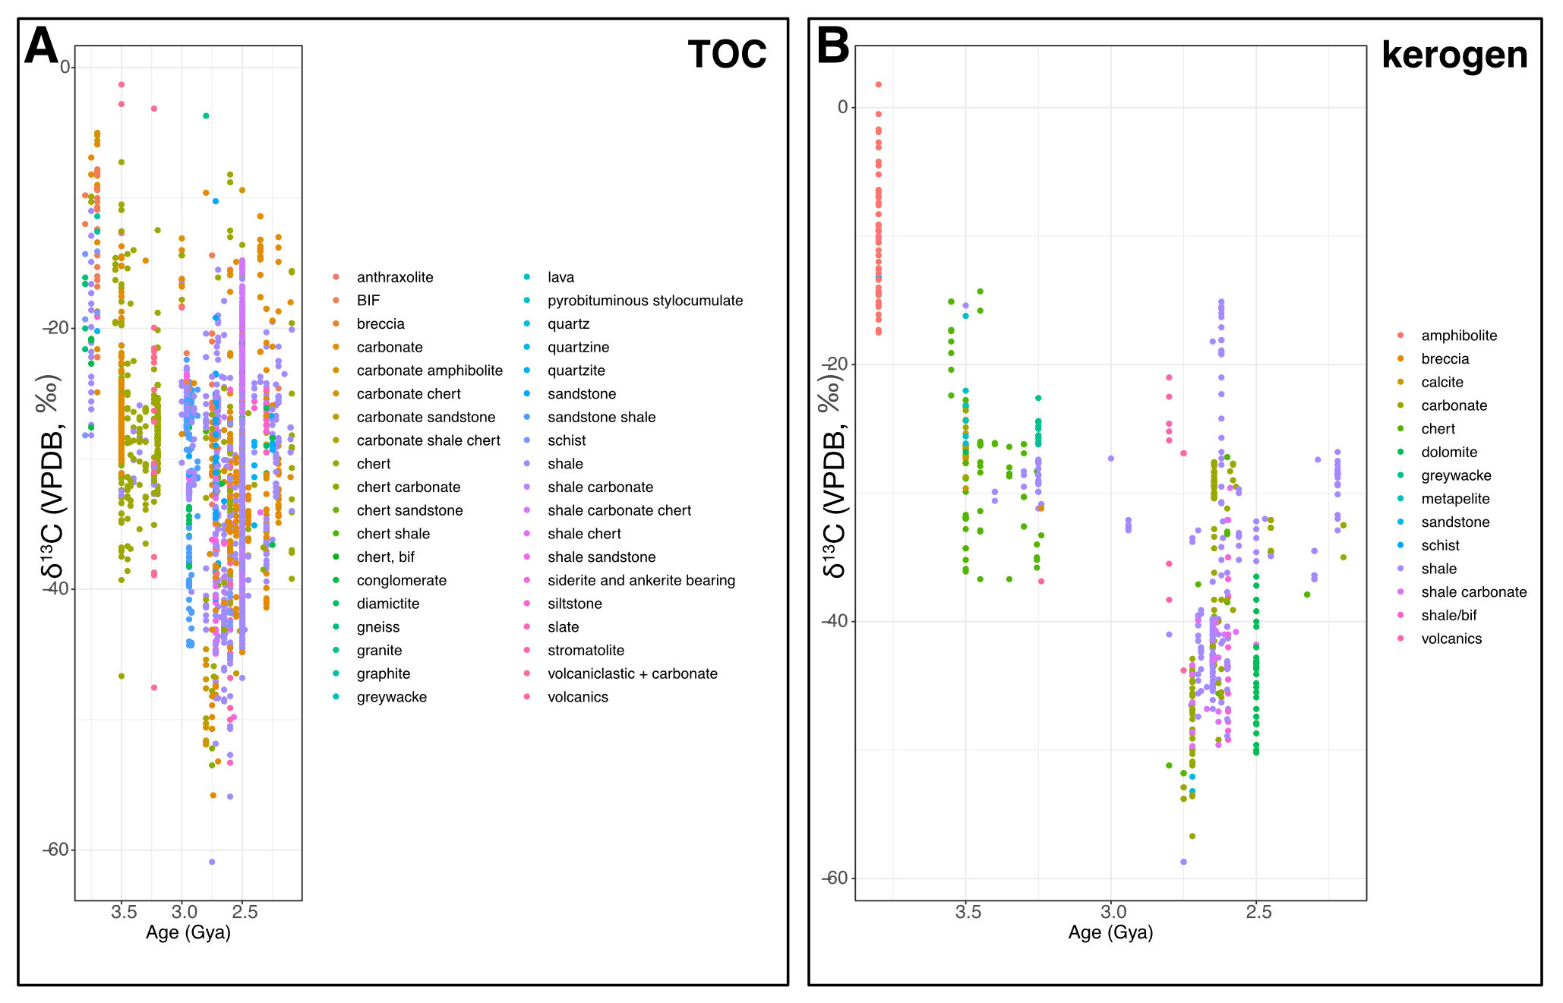

Supplemental fig 2. Catagenesis model sensitivity analyses for different natural gases. Changes in δ¹³C_{org} value during catagenesis based on a simplified model of homolytic cleavage of methane from kerogen, which leads to a decrease in H/C ratio. Each brown line represents a model run where a different gas is produced, where lighter is a gas with a lower number of carbon atoms. All model runs begin with δ¹³C_{org} = -33‰ and α = 0.975. s is the number of model steps that it required to reach an H/C ratio = 0.1. Grey and black triangles are compiled data from Des Marais, 1997 and are the same as the data presented in fig 6A.

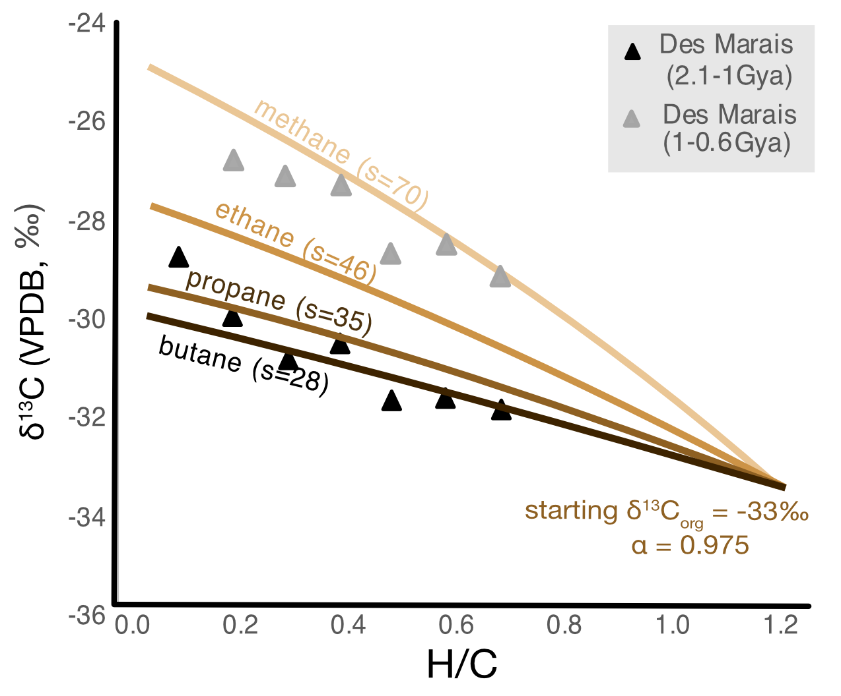

Supplemental figure 3. Case study of ~2.7 Gya organic carbon. Kernel density estimates for δ¹³C values of kerogen (dashed black line) and TOC (black line) versus lithology-specific δ¹³C values of TOC (dotted lines) for (A) Tumbiana Fm., (B) Fortescue Group, (C) Hamersley Group. (D) Comparison of the kernel density estimate for δ¹³C values of TOC for units from different cratons with samples 2.65-2.8Gya. TOC; total organic carbon.

